NASA Capstone

**Assessing the Quality of GLOBE Water Transparency Data**

Andy Henning

Charles Wallace

Cory Charles Platt

David Rivers

Jessica Gochioco



A Capstone Project Report in the Field of Data Science

For the Degree of Master of Liberal Arts in Extension Studies

In Collaboration with the National Aeronautics and Space Administration

Harvard University May 2025

# **Abstract**

The GLOBE program1, sponsored by NASA, is at the forefront of citizen science efforts, offering a pathway for amateur scientists to contribute environmental data for the benefit of the broader scientific community. Since 1995, GLOBE has amassed an extensive library of large datasets, but most go underutilized due to mistrust of the data and lack of verifiability. Indeed, Amos et al. (2020)2 performed an evaluation of GLOBE data from 2016-2019 and flagged 7-13% of submitted data as potentially inaccurate.

This project focused on validating GLOBE’s water transparency dataset, which is key to understanding the health of our global water resource. In collaboration with NASA scientists, Dr. Kelsey Bisson and Dr. Ivona Cetinić, and in partnership with a second team, were able to validate and score the measurements of the transparency dataset. As we have two teams working on this project, we have split the project into two parts. This paper is focused on our team’s work to provide additional metadata to the GLOBE dataset, which served as helpful features for our partner team to use in anomaly detection models. The metadata we provided was (1) the distance of observation from a water body edge, (2) water body type classification, (3) an estimate of water transparency tube length, (4) water depth, and (5) a matched Kd-490 value.

While the metadata proved highly useful and opened new paths for validation and analysis, we encountered limitations with API throttling, resolution mismatches, and dataset sparsity. Ultimately, time constraints prevented full integration into the anomaly detection model, but our work lays a strong foundation for future efforts. Our findings emphasize the need for streamlined remote sensing access, enhanced metadata pipelines, and greater cross-team coordination to realize the full potential of citizen science datasets like GLOBE.

Looking forward, the vision is for each new GLOBE submission to be interpreted and scored by the model. In this way, the model will be able to discern uncertain data points from those with higher confidence, enabling scientists to make independent decisions on which data to employ for their research.

# Acknowledgements

We would like to extend our gratitude to our scientific sponsors, Dr. Kelsey Bisson and Dr. Ivona Cetinić, whose guidance and consistent support helped shape our work throughout this capstone. Their availability, encouragement, and efforts to connect us with other scientists in the community ensured our project remained grounded in real-world impact. Much of our direction and success can be attributed to their involvement, and for that we are deeply thankful. Their dedication to advancing open science was a continual source of motivation and inspiration, helping us see the true value of this data through their eyes.

We are also grateful to the modeling team for their close partnership and collaborative spirit. Their technical expertise, clear communication, and willingness to align with our capabilities made it possible to explore and iterate effectively within a constrained time. The synergy between teams allowed us to move quickly, share feedback fluidly, and ultimately strengthen both the data and modeling outcomes.

# **Table of Contents**

**Abstract** **ii**

**Acknowledgements** **iii**

**Table of Contents 1**

**Chapter I: The Problem 3**

Setting / Problem 3

Theoretical / Conceptual Framework 4

Proposal Overview 6

A Priori Hypotheses 7

Variables and Key Concepts 7

Domain Specific 7

Methodology Specific 7

Assumptions, Delimitations, and Limitations 8

Importance of the Study 9

**Chapter II: Literature Review 10**

Introduction and Context 10

Previous Anomaly Detection Efforts in GLOBE Data 10

Large language models 11

Satellite Imagery Water Extraction 12

Previous Satellite Imagery and Citizen Scientist Observation Studies 13

**Chapter III: Methodology 14**

Data Collection 14

GLOBE Observation Metadata Calculation 14

Distance of Observation from Water Body Edge 14

Transparency Tube Length Estimate 15

Water Body Classification via Language Model Conditioning 17

Depth Estimation Using the GEBCO Dataset 19

Kd Analysis: A Proxy for Water Clarity 19

Assumptions, Risks, and Limitations 20

Assumptions 20

Risks 20

Limitations 21

Ethical Considerations 21

Legal Considerations 21

Trustworthiness of Data 22

Timeline of Execution 22

**Chapter IV: Analysis 23**

Overview of the Data 23

Water Body Classification 23

Model Quality Assessment 25

Chi-Square Test of Independence 25

Cramér's V 25

Manual Audit with Remote Sensing Imagery 26

Limitations and Future Enhancements 26

Water Distance Analysis 26

Transparency Tube Length Estimate Analysis 32

Depth Analysis 36

Kd Analysis: A Proxy for Water Clarity 36

Why 490 Matters? 36

Relationship Between Kd₄₉₀ and Secchi Depth 37

Empirical Evidence 37

Satellite Remote‑Sensing Data Analysis 37

Analysis on GLOBE Hydrology Protocols 39

Secchi Tube Input Misinterpretation 39

Water Body Type 40

Transparency Tube Measurements 40

Enhanced Input Validation Using Machine Learning 40

Photo Based Measurement 40

Swarming Measurements for Increased Confidence 40

**Chapter V: Findings / Conclusions 41**

Metadata Findings 41

Water Distance 41

Transparency Tube Length 41

Water Body Classifications via LLM 42

Depth Considerations 42

Satellite-Derived Kd-490: Promise and Limitations 42

Protocol Recommendations 43

Two Team Approach 43

Future Recommendations 43

Conclusions 44

**References 45**

# 

# **Chapter I: The Problem**

## Setting / Problem

GLOBE, a citizen science initiative sponsored by NASA and other government agencies, has been dedicated to promoting scientific literacy and building connections among individuals passionate about the environment and since its launch on Earth Day in 1995 GLOBE has obtained an extensive hydrologic dataset. Despite the program's lifespan, GLOBE’s extensive citizen science datasets, spanning three decades, have remained largely underutilized.

A major cause for this is the overall opinion of citizen scientist observations is due to the data suffering from inconsistencies due to variations in collection methods, observational expertise, and environmental conditions. All of which contributes noise in the data. This dataset poses a challenge for researchers who need accurate, validated data for in-depth studies.

The importance of this data though cannot be overlooked. Studying Earth’s water systems requires widespread, continuous data collection, a task that increasingly depends on global participation. While satellites and remote sensors are a huge boon to the gathering of data and insights to the world they are unable to penetrate all corners of the globe.

Today, participants from 127 countries contribute environmental data on an ongoing basis, creating an expansive, distributed network capable of generating large volumes of valuable information. As part of the hydrology component of the GLOBE Program, citizen scientists collect water quality and transparency data worldwide. Water is critical in sustaining life on Earth, influencing food security, climate, and overall health.

NASA scientists, including our sponsors Dr. Kelsey Bisson and Dr. Ivona Cetinić, have identified several key limitations in the GLOBE transparency dataset that impacts its reliability and utility by the scientific community:

* **Protocol Deviations and Equipment Variability**

The equipment used by citizen scientists can vary from homemade vs standardized Secchi disks along with deviations from prescribed observation protocols. These can introduce errors and unrealistic values in a geophysical sense (i.e., negative transparency depth), undermining the trust of the dataset’s integrity.

* **Temporal and Regional Variability**

Over the three decades the GLOBE program has been operating there has been evolution in the protocols, data recording methods, and regional variances to resources vary greatly. This has resulted in variance in water clarity readings and incomplete supplemental site data.

* **Environmental and Seasonal Variability**

Depending on the water body, water clarity can be sensitive to short-term impacts such as recent rainfall, algal blooms, seasonal runoff, or ephemeral all together. These local and temporal conditions can massively impact transparency readings, especially in areas where in-situ measurements are sparse or temporally unaligned. This natural variability adds additional levels of noise to account for.

* **Human Error and Data Entry Issues**

Manual data contributes to inaccuracies which are caused by human error. These can be difficult to detect and correct, particularly when the site data is missing or incomplete.

* **Lack of Quality Control**

The capturing of GLOBE data lacks a robust centralized quality control process. Without validation or flagging of suspect values, potentially erroneous data remains uncorrected.

* **Geographic Sampling Bias**

The dataset contains overrepresentation of certain locales. Those being observations from well-resourced or highly active regions. This in turn has introduced spatial bias, limiting the ability to detect regional trends in under-sampled areas and make globally representative inferences.

Addressing the data quality issues and providing effective validation tools will be a major step toward unlocking the dataset’s potential. This effort will empower the broader scientific community, policy makers, and citizen scientists to contribute more effectively to water quality management and environmental stewardship.

## Theoretical / Conceptual Framework

In this project, we attempted to prove that citizen scientist in-situ data when properly contextualized can contribute value to global scientific inquiry. The challenge is, variations in the data collection process have introduced multiple sources of noise, overrepresentation, and human error.

We addressed these challenges by matching GLOBE measurements with independently derived metadata. This enabled us to cross-validate data, identify anomalies, and improve overall dataset reliability. By contextualizing these measurements with consistent metadata, we aimed to reduce uncertainty and improve the scientific utility of the dataset.

One major hurdle faced with the GLOBE water transparency dataset is the reliability of site-level data. These observations are occasionally recorded in non-natural environments (fountains, classroom tubs, or puddles) which complicate downstream interpretation. To address this, we captured the distance of measurement locations to observed water bodies by satellites. This step helps distinguish valid observations from those that are not aligned with the scientific intent of the protocol.

Another notable issue is with tube saturation, specifically where the water transparency tube is fully filled, yet the Secchi disk remains visible. This means the observation is not actually measuring the visibility but that the lower bound was reached in the tube. Many observations do not indicate that the tube was saturated, even though the recorded depth is equal to a common tube length. This misunderstanding may lead to incorrectly concluding that the image disappeared at that particular depth. To overcome this we estimated the total length of the tube used for each GLOBE water transparency observation using two methods: (1) an algorithmic approach and (2) maximum likelihood estimation (MLE). Using these estimates we provide a depth index, which is defined as the normalized measured depth (i.e observed depth over the total length of the tube).

Beyond correcting individual measurements, this project tackles how water bodies are categorized across the GLOBE dataset. The supplementary site measurement metadata procured from the GLOBE website includes 28,175 unique observation locations called sites. However, fewer than 40% of these records contain a reliable field describing the surrounding water-body type. This presents a significant challenge, as expected turbidity levels can vary substantially between different water bodies, such as rivers, ponds, oceans, and man made, having accurate classification is critical for meaningful validation and scientific utility.

At this scale and for future ongoing data, manual annotation of missing or ambiguous classifications is not feasible. To overcome this challenge an expert-informed classification pipeline was created that leverages a large language model (LLM) trained on hydrology-specific literature and GLOBE metadata which we named IvonaBot after Dr. Ivona Cetinić, a distinguished NASA oceanographer and one of our project's sponsors. By processing all data provided ranging from location descriptions, site notes, and spatial context, the LLM is able to infer likely water-body types even in the absence of explicitly labeled data. This approach enables more consistent classification across regions where official datasets are sparse or protocol adherence varies, ensuring a more reliable foundation for downstream analysis.

We also account for systematic biases, those stemming from variability in instrumentation, observer skill, and regional protocol adherence. By layering derived metadata onto GLOBE records, we can better identify outliers, reveal patterns in data quality, and inform best practices for future GLOBE hydrology protocol refinements.

Another key component of this contextualization is depth when interpreting transparency readings. If a Secchi disk reading is 1.5 meters but the water body itself is only 1.5 meters deep, this limits the conclusion we can draw about water clarity. Conversely, a reported 10-meter transparency in a 2-meter-deep lake would indicate a likely error. Importantly, depth can also feed into models estimating Kd. Although Kd estimation is not explored in this paper we capture Kd values and this ensures we enable future analyses.

Additionally we integrate with satellite derived data like Kd-490, the diffuse attenuation coefficient of light in water, which quantifies how quickly light diminishes as it penetrates deeper into the water column. We capture Kd-490 values for each record, which enables validation of in-situ measurements and facilitates broader-scale optical water quality assessments.

Ultimately, the enriched and standardized metadata produced through this project is being handed off to a modeling team responsible for quantitatively evaluating the accuracy and reliability of GLOBE transparency measurements. By adding additional metadata and improving classifications, we enable the modeling team to better assess the in-situ measurement quality, detect anomalies, and enable the ability for this data to provide meaningful scientific insights.

### 

## Proposal Overview

**Water Body Classification and GLOBE Observation Metadata Collection**

The objective of this project is to augment the existing GLOBE transparency data with reliable supportive metadata. This will lead to an overall enhanced dataset which will suppose subsequent anomaly detection efforts led by the modeling team.

To do this we used raster-based satellite data from Sentinel-2 and Sentinel-3, which enables the determination of distance to a body of water along with dynamic detection of water features, including accounting for seasonality. MODIS-Aqua data is also leveraged for broader-scale analysis of water clarity, though with noted limitations due to its 4 km resolution.

Each GLOBE measurement is geospatially aligned with the nearest relevant water body derived from the provided lat long cords. This enables the calculation of key metadata, including:

1. **Distance from the water’s edge**: Using high-resolution Sentinel data to gauge proximity.
2. **Tube length estimate**: Estimated total length of the tube using two methods: (1) an algorithmic approach and (2) maximum likelihood estimation (MLE)
3. **Water body classification**: Applying a classification model trained on hydrological literature and GLOBE site data to classify the water bodies.
4. **Estimated water body depth**: Using bathymetric data from GEBCO to add vertical context.
5. **Diffuse attenuation coefficient (Kd)**: Derived from Sentinel and MODIS data to quantify light penetration in the water column.

This metadata, gathered independently of one another, was integrated to create a cohesive dataset to support the validation conducted by our partner team. Their team goal is to use this enhanced dataset to validate the GLOBE transparency data, and build trust of the data with the global scientific community.

## A Priori Hypotheses

We hypothesize that by providing critical metadata for each GLOBE water transparency data point, our efforts will support advanced anomaly detection systems, specifically those incorporating satellite imagery data. This in turn will significantly enhance the reliability of the GLOBE program’s hydrologic dataset. The process of integrating GLOBE data with satellite imagery will strengthen the validation process by providing a consistent, independent reference for diverse global observations. Additionally, insights gained from this approach can inform updates to data collection protocols, reducing future inconsistencies and fostering greater participant engagement by offering clearer and more actionable guidelines.

## Variables and Key Concepts

### Domain Specific

* **Citizen Scientists**: Volunteers who contribute information to a scientific study by following set protocols for data measurement.
* **Water Transparency**: A characteristic of water defines the depth light can penetrate a water column. It is often used as an indicator of water, as higher transparency typically corresponds to clearer water.
* **Remote Sensing**: Measuring environmental metrics on earth using selected components of electromagnetic spectrum, most commonly viewed from satellites.
* **Water Index**: Remote sensing products identifying water bodies from satellite imagery, such as the Sentinel-2 and 3 imagery.
* **Satellite Data**: Provides macro-scale environmental metrics. Satellite data serves as an independent reference for validating in situ measurements, ensuring more accurate cross-comparison of global observations. Several satellite programs will be leveraged for this project, including Sentinel-2 and Sentinel-3 for water transparency (KD) and distance from water body calculations, along with MODIS and GEBCO for additional environmental and depth data.

### Methodology Specific

* **Satellite Data Integration:** Satellite imagery from Sentinel-2 and Sentinel-3 will be used to obtain distance to water and Kd.
* **Water body classification:** Five water body categories derived using a large language model (LLM) trained on a NASA scientist’s hydrological research and GLOBE site descriptions.
* **Globe Site Data Acquisition:** Globe research site metadata was obtained by scraping the GLOBE website. This data provided water body classification details linked to each site ID, serving as the foundation for generating consistent classification labels across the dataset.
* **Depth Data:** GEBCObathymetric data was used to determine estimated water depth for each site location.
* **Feature Extraction**: The process of creating Vector data outputs from an input Raster dataset.

### 

## Assumptions, Delimitations, and Limitations

We assume that GLOBE participants earnestly follow their respective protocols, yet acknowledge that differences in training, instrumentation, and local conditions introduce variability.

Though satellite data offers global coverage, often their low resolution and surrounding objects like trees can obscure smaller rivers and streams, leading to incomplete water body mapping in some regions. We supplement these gaps with water vector datasets where available but must remain aware that no single source perfectly captures all water features.

We further split our initial dataset to areas with higher GLOBE data density, ensuring we have enough ground observations for meaningful comparisons. This approach could expand to include regions with sparser citizen science contributions but for this project it was limited. Lastly, the dynamic nature of aquatic environments, driven by seasons, climate variability, and local events, limits the extent to which any single datapoint can fully represent water quality conditions.

**Data Bias Considerations**

Citizen science contributions often come disproportionately from well-resourced regions or more accessible water bodies. This can result in geographic bias where certain continents, countries, or specific water types (e.g., lakes near urban centers) are overrepresented. Additionally, volunteer training can vary significantly between school groups, private organizations, and independent contributors, generating potential systematic differences in reported measurements. Recognizing and adjusting for these biases will be critical in interpreting results and ensuring robust comparisons across global datasets.

### 

## Importance of the Study

A robust and validated hydrological dataset from GLOBE stands to benefit researchers, policymakers, and local communities alike. By merging ground-truth measurements with satellite imagery and supplemental vector sources, this project can contextualize citizen science reports, thus enabling a more accurate interpretation of global water clarity trends. The integration of satellite-derived metadata provides an independent reference, helping assess the reliability of individual observations and offering critical context that strengthens the overall dataset's scientific credibility.

This in turn has several tangible outcomes. Enhanced water resource management will enable better prioritization of interventions and effectiveness of conservation efforts over time. With standardized, higher quality open source water clarity records, greater scientific collaboration becomes possible, opening new opportunities for joint research across different regions and disciplines.

Additionally, stronger citizen science engagement is expected as participants see their data contributing meaningfully to research and policy, thereby increasing public trust and involvement in environmental monitoring. Insights gained from comparing in-situ measurements with high resolution satellite or vector data will also inform protocol refinements, shaping more consistent and user friendly guidelines for future GLOBE observers. At its core, this project helps build trust in citizen science data by increasing transparency, enabling independent validation, and strengthening its usability for the broader scientific community.

# **Chapter II: Literature Review**

### 

## Introduction and Context

There is broad application for data validation within the field of citizen science, particularly by referencing observations against other unbiased data sources. In the absence of data for direct measurement of the desired metric, proxies or metadata may be useful for citizen science data validation. NASA has listed some metadata that can be helpful specifically for GLOBE water transparency observation validation. Additionally, upon review of the GLOBE dataset, some other potentially useful metadata has become apparent. Valuable GLOBE water transparency metadata includes: (1) distance from the observation point to known water bodies, (2) classification of the collection site water body, (3) an estimate of water transparency tube length, (4) water depth, and (5) a matched Kd-490 value.

## Previous Anomaly Detection Efforts in GLOBE Data

Citizen science data has extensive reach and has the potential for high impact, but issues with data accuracy and anomalies remain a hindrance to widespread use among the scientific community. Amos et al. (2020)2 suggests that citizen science data can be particularly beneficial, especially when the protocols are strongly defined and there are checks in place to flag anomalous data points. Amos notes that GLOBE has made efforts to proactively prevent or remove erroneous data from downstream applications. One recent program aimed at resolving such data discrepancies was the development of the GLOBE Observer App in 2016. The GLOBE Observer App aided data collection and provided feedback and suggestions directly to the user. Overall, 7.8% of data submitted via the app from 2016-2019 was flagged as potentially inaccurate, whereas 13% of data submitted through traditional GLOBE channels was similarly flagged as potentially inaccurate during the same time period. The GLOBE Observer App program shows that the implementation of new technologies can improve data accuracy, even when applied to established data collection protocols.

As discussed above, the GLOBE program has previously utilized basic data verification for incoming observations. These flags are simple checks on the data, and are consumed by downstream clients who selectively remove data depending on the flags they deem relevant for their use case. For example, if a GLOBE observer has recorded their location over water when they should be on land. Going forward, more robust tooling is needed to identify potential inaccuracies that can only be uncovered by cross referencing multiple data sources. Any such effort will rely on additional metadata supplied for each GLOBE observation. Potential metadata sources may be intrinsic or external to the GLOBE data, such as aligning the observation location with water extracted from satellite imagery. Such metadata would serve as an unbiased indicator of the validity of GLOBE ground truth data.

## Large language models

There have been recent advancements in Large Language Models (LLM), combining explainable artificial intelligence (XAI). These efforts have been explored for potential remote sensing water quality monitoring. Traditional water monitoring techniques, although effective in localized scenarios, often suffer from scalability issues, high maintenance costs, and delays due to laboratory analysis, making them unsuitable for broader, rural, or resource-limited settings. To address these challenges, researchers have increasingly leveraged the combination of remote sensing data, machine learning models, and interpretable AI frameworks.

For example, Noman et al. (2024)3 proposed an innovative framework that combines satellite and UAV data with advanced AI techniques, emphasizing the use of LLMs for improved data processing and perspective formation. Their framework utilized Random Forest and Gradient Boosting Machines to predict water quality indicators such as turbidity and chlorophyll-a concentration. The integration of XAI techniques within this framework ensures transparency and builds stakeholder trust, particularly in resource-constrained environments.

These innovations shift unexplainable black box methods towards transparent and scalable solutions. Our capstone project has similar objectives to predicting the turbidity of water bodies to help identify anomalies in the GLOBE dataset. Not all methods from Noman's framework will be used, but the ensemble of vision and LLM should enhance the GLOBE dataset's explainability.

Ren et al. (2024)4 research on domain-specific large language models (LLMs) through the development of WaterGPT, a bilingual (English–Chinese) system tailored to hydrological science. Building on the idea of similar digital practitioners such as DoctorGLM (medicine) and LawGPT (legal studies), WaterGPT is explicitly designed to serve hydrologists and water-resource managers. WaterGPT training data combines general linguistic knowledge sourced from English and Chinese Wikipedia. Domain expertise was learned by the Water Conservancy-SFT dataset, a curated collection of question–answer pairs covering hydrological processes, instrumentation, and field practice. To further diversify learning in the area of hydrology, synthetic data was generated by ChatGPT-3.5 and GPT-4 in the same question-and-answer methodology.

WaterGPT’s efficacy was evaluated against six well-known foundation models (GPT-4, ChatGPT, Qwen-7B-Chat, InternLM2-Chat-7B, ChatGLM3-6B-32K) using a 1,149-item multiple-choice examination drawn from a professional hydrology dataset. WaterGPT achieved an 83% accuracy rate, significantly surpassing the other models' group average of 61 %. This performance gap displays the advantage of domain-specific machine learning.

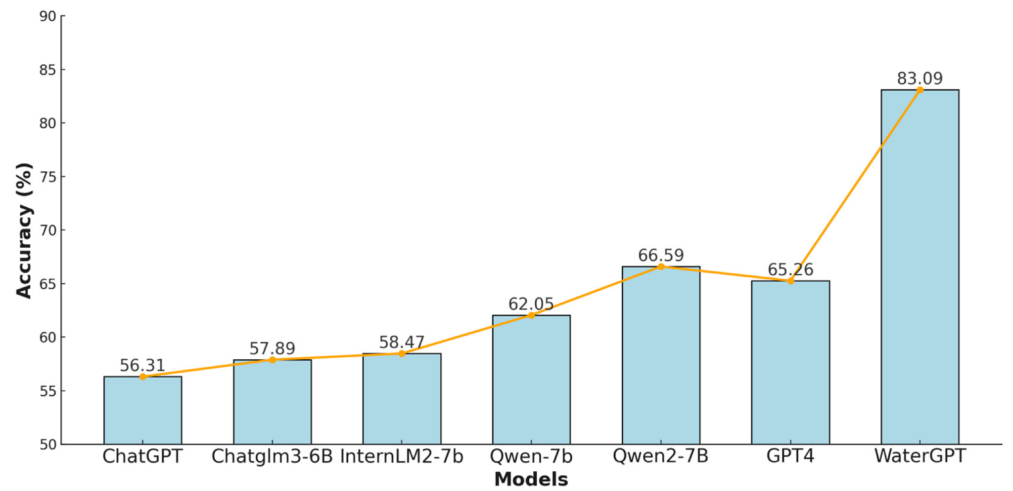

For projects such as NASA’s GLOBE hydrology initiative, WaterGPT offers two immediate benefits. First, it can act as an on-demand expert, answering technical queries when human subject-matter specialists are unavailable. Second, its domain sensitivity positions the model to perform intelligent data enhancement tasks, such as imputing missing attributes (e.g., water-body type) by synthesizing cues from partially populated records. These functions not only could elevate dataset quality but also unlock opportunities for anomaly detection.

## Satellite Imagery Water Extraction

There have been many studies aimed at isolating water bodies from rasterized satellite imagery. Remote sensing techniques form the basis for most early water classification algorithms. The current benchmark methodology is the Normalized Difference Water Index (NDWI), which was first introduced by Gao (1996)5 to assess agricultural health, and subsequently modified by McFeeters (1996)6 for water body detection. It is a widely accepted and standardized remote sensing algorithm that extracts water bodies from imagery using the normalized difference of the visible green wavelength and the near-infrared wavelength. One well known issue with NDWI is that shadows of tall buildings or any other geographical features that have low albedo or reflectivity can often be mistaken for water. In response, a further modified version of NDWI using a middle infrared band rather than a near-infrared band was proposed by Xu (2006)7, which performed better in regions with water bodies near built-up land areas. Subsequently, Jiang et al. (2014)8 also noted this issue, as well as difficulty identifying narrow rivers and streams. They proposed a standalone algorithm using image processing techniques and multiple water detection indices, including the NDWI, to classify water in Landsat imagery. Similarly, Kaplan et al. (2017)9 put forward a technique that uses image preprocessing and non-learning object based image classification techniques using water indices data. Remote sensing techniques have been shown to identify water bodies with high accuracy, but have known issues since they are deterministic algorithms rather than trained networks.

In recent years, numerous studies have further improved upon the NDWI algorithm by implementing machine learning techniques, primarily Convolutional Neural Networks (CNNs). Often these solutions are multistage models, where each stage is trained to perform a distinct image processing or object classification task. For example, Huang et al. (2015)10 proposed a two-level CNN model that first classifies water bodies within imagery and then further refines the boundaries of these water bodies from their extracted vector objects. This pixel and object based approach is helpful because it also provides an understanding of water type, such as a pond, lake or stream. Similarly, Chen et al. (2020)11 outlined a series of three separate CNN-based models for water body feature enhancement, context extraction, and boundary refinement, which achieve nearly 99% accuracy in water body identification. Most recently, Li et al. (2024)12 proposed a novel CNN named CRAUnet++, which identified water bodies in Sentinel-2 satellite imagery with a >95% F1 score. CRAUnet++ uses ResNet34 for feature extraction and takes advantage of various attention mechanisms that reduce background noise and boost water signal. It also employs other information-rich metadata such as the vegetation red edge-based water index (RWI), which is a recently proposed, though less common, remote sensing algorithm for water body identification (Wu et al., 2018)13 that further attempts to reduce imaging noise produced from neighboring urban areas. In this way, CRAUnet++ combines the robustness of machine learning processes with remote sensing algorithms in order to improve accuracy in situations where pure remote sensing strategies were lacking. Recent machine learning models have greatly improved upon basic remote sensing approaches for water body classification, and also allowed for the collection of valuable water body metadata.

It is important to note that there exists a multitude of image classification algorithms to extract clusters from imagery data, especially from satellite imagery. While some advanced techniques are mentioned above, there are some basic practices for geographic feature extraction that are readily available and practical for a variety of applications. This study examined a subset of algorithms, and deployed those that are both effective and best fit within the constraints of the GLOBE water transparency use case.

## Previous Satellite Imagery and Citizen Scientist Observation Studies

This study seeks to extract water body metadata, primarily from satellite imagery, and apply this information to citizen science data (i.e. GLOBE water transparency data) for the purposes of data validation. NASA has used the fusion of satellite imagery and citizen science data in the past and it has proved helpful, especially in situations where satellite imagery is ineffective due to cloud or tree cover, or there are temporal constraints. For example, NASA has previously worked with citizen scientists to measure the extent of lakes and reservoirs, particularly water bodies produced by seasonal flooding. These water bodies are only available for study for relatively brief periods at certain times of the year, and they are commonly occluded by cloud cover during this time. This program, the Lake Observations from Citizen Scientists and Satellites (NASA, 2020)14 program, relied on imagery from Landsat 8, Sentinel 2, and Sentinel 1 earth observation satellites as well as over 3,000 lake height measurements from over 1,000 citizen scientists. Using this dual data collection approach, NASA was able to calibrate their satellites to precisely capture the extent of these water bodies. The union of satellite imaging and citizen scientist data greatly enhances the speed, scope, and quality of data collection since both methodologies complement each other.

# Chapter III: Methodology

### 

This chapter outlines the methodology used to compile, structure, and enrich the GLOBE transparency data. Building on the project objectives covered in Chapter II, we are capturing and combining relevant metadata to help enhance and validate citizen science observations through geospatial data, satellite comparison, and site classification. The finalized dataset is intended to be handed off to a modeling team, who will use these metadata features to determine measurement quality and generate scoring models. This chapter focuses on the technical processes used to prepare the metadata for those downstream modeling efforts.

## Data Collection

The foundation dataset for this project, GLOBE transparency, is freely available at [GLOBE.gov](http://globe.gov) and contains the measurement data (Secchi depth) of the in-situ observations. This is limited though in contect and so to provide additional context the GLOBE unique site data was obtained. This was done directly from the GLOBE website site through scraping completed by the modeling team. This site data is highly qualitative, spans across multiple different languages, and is often incomplete.

We combined both sources using the site id between sources as the key which provided the foundation of the data mapping.

## GLOBE Observation Metadata Calculation

### Distance of Observation from Water Body Edge

We verified the existence of water using two sources: OpenStreetMap and high resolution Sentinel-2 satellite imagery. First we queried the OpenStreetMap API for water features since the vector map API queries information much quicker than downloading and processing satellite imagery files. The OpenStreetMap vector maps database contains water bodies, such as small streams, creeks, or lakes under tree cover, that may not be visible in satellite imagery. If our initial query of OpenStreetMap returned a water body within 300m (chosen since this is likely a 5 min walk from the listed observation coordinates), then we submitted that water body distances for the sample, and did not query satellite imagery. If OpenStreetMap was not able to return a water body feature within 300m, then we also queried Sentinel-2 high resolution (10m) satellite imagery for water using the Google EarthEngine API, and returned the minimum distance to water between the two data sources. OpenStreetMap is an open source map provider with known coverage gaps, so it was not assumed that they have global coverage of all water bodies. In particular, we noticed that extremely large water bodies, such as oceans, are often not returned by the OpenStreetMap API when a small 1km region is requested. However, typically GLOBE water transparency data is limited to smaller inland water bodies where citizen scientists are located, and water transparency samples taken from boats in oceanic environments are often labeled as such, leading to little confusion. Satellite imagery is generally able to identify many of the remaining water bodies. For example, there may be seasonal water bodies that potentially only exist in satellite data.

We used the standard approach of the normalized difference water index (NDWI) algorithm for extracting water from satellite imagery. We chose any available satellite imagery within the history of Sentinel-2 program, which was initially launched in 2015, in order to minimize false negative results as much as possible. We also only chose imagery where cloud cover was less than 5% of the image to ensure our conclusions were accurate.The Sentinel-2 high resolution satellite imagery is a 13 band dataset, where each band collects light at a particular wavelength. Following the procedure outlined for the normalized difference water index (NDWI), we used the normalized difference of band 3 (559nm - green) and band 8 (864nm near infra-red), as shown below (McFeeters, 1996)6

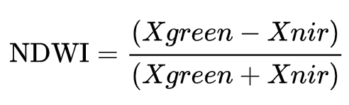

According to the NDWI algorithm, if the NDWI value was >0.3 then we considered that imagery pixel to be water and colored it black, otherwise we considered it to be land, and colored it white. We performed post-processing during a single pass over the image, and if a pixel had neighbors that were water, we colored that pixel black and assumed it was water as well. This created continuity of water bodies in our output imagery and reduced noise.

Finally, we computed the distance from water for each observation latitude / longitude point. If the distance came from OpenStreetMap we used the haversine formula, and if the distance came from 2D high resolution satellite imagery we used the pythagorean theorem to estimate the distance. If no water was found within a 1km bounding box of the collection site location, we recorded the distance as exactly 1000 meters, representing a ‘none’ value. We also recorded the source the algorithm used to measure the distance to water as: ‘osm’, ‘imagery’, or ‘none’. In this way, downstream clients may choose to base their filtering on one verification source, and we also used this information for debugging and reverse engineering of our algorithm.

### Transparency Tube Length Estimate

We determined the true GLOBE water transparency tube length using two similar approaches. Five potential tube lengths were considered, based on their perceived ubiquity: 27cm, 45cm, 60cm, 80cm, 100cm, 120cm. Each sample had to be matched with one of these 5 categories. Only water transparency observations between 0cm and 120cm were considered valid, otherwise the output was labeled as N/A. Many of these N/A values are not necessarily unusable - they may have just used different instrumentation, such as a Secchi disk, which is not applicable to this specific metadata contribution.

The breakdown of GLOBE water transparency observations are as follows:

* 22% of observations (totaling 34.7K) are N/A.
* 44% of observations (70K) have measurements that exactly match a common tube length, meaning they are potentially saturated measurements (water filled to the top of the tube).
* The remaining 34% of observations (55K) have valid measurements that do not match a common tube length exactly, and thus may not be saturated measurements.

We exploited the fact that 44% of total observations, and 56% of valid observations, matched a common tube length exactly. We built models and labeling algorithms to identify the tube length used for any observation, using this information as a strong indicator of tube length.

*Algorithmic approach*

The first method employed our intuition about the water transparency measurement protocol, and the data we observed, to extract the tube length according to a set of rules.

Below is the algorithm, 5 outcomes are possible:

1. If this is the first sample at that site or country (depending on the unit of aggregation), assume the tube length is 120cm, which is simply the longest length. This avoids any issues with the measurement being longer than the estimated tube length.
2. If the sample is exactly the same length as a common tube length (shown above), then consider that the true tube length.
3. If the sample is >100cm then the tube length must be 120cm.
4. Finally, assume the tube length is the most common exact tube length measurement taken at that site or country.
5. Although, if the sample is still longer than the mode produced in Step 4, then assume the tube length is the next longest common tube length that is just longer than the sample.

This algorithm is predicated on our intuition that many measurements are saturated, even if they are not labeled as such, and thus the most common measurement is the saturation depth (tube length).

*MLE approach*

We used a Categorical distribution with a Dirichlet conjugate prior, and performed Bayesian updating of the concentration parameter. The resulting distribution was a Dirichlet distribution, and the estimated tube length was the most likely valid category. During prediction, we ignored tube lengths that were shorter than the observation, since this was an impossible scenario.

Steps are provided below:

1. *Pre-processing*: Time order the measurements for each site or country, and process each site or country individually, since they are assumed to use similar instrumentation over time.
2. *Prior knowledge*: Initially, assume a naive prior concentration parameter for each site (i.e. a uniform distribution).
3. *Estimating*: Assess each measurement, and estimate the tube length as the most likely commonly used tube length that is longer or equal to the measurement.
   1. In the case of ties, take the longer tube length.
4. *Updating*: If that measurement matches a common tube length (in the case of saturation), then update the concentration parameter by adding 1 to the index that represents that tube length
5. *Iterating*: Repeat steps 1-4 for all samples at that site, and again for each site or country.

The maximum a-priori estimate for each sample is given by the mode of posterior Dirichlet distribution, which is the vector (*x*1, ..., *xK*), shown below (modified from Bishop, 2006)15.

𝑥𝒾 ∝ 𝛼𝒾 - 1, 𝛼𝒾 > 1

Here 𝛼 is the prior concentration parameter, which is initially 1 in the case of a uniform prior. 𝛼 is updated according to the methodology described in Step 4 above. The mode of the Dirichlet distribution is a probability mass function (pmf) representing the likelihood of selecting any particular tube length. As described in Step 3 above, the tube length estimate is designated as the one that is indexed to the maximum value within this pmf that is also equal to or longer than the observed measurement. Again, note that Step 4 states that updating of 𝛼 only occurs if the observed tube length exactly matches a known tube length. These situations are hypothesized to provide strong confirmation of the true tube length.

The overall motivation behind this methodology is for the model to determine the most likely tube length by identifying saturated measurements, which is similar in concept to the algorithmic approach also described above.

### Water Body Classification via Language Model Conditioning

To classify water body types in a manner that can handle scale and not be manually intensive, a prompt-based large language model was implemented that classifies each data point as one of seven categories: *River/Stream*, *Pond/Lake*, *Marsh*, *Ocean*, *Non-natural water source*, *Inconclusive*, or *Insufficient Information*. This process after conditioning the LLM relied exclusively on metadata provided on the GLOBE website, without the use of additional outside data.

To obtain the site metadata provided on the GLOBE website, the modeling team scraped metadata directly from the GLOBE program website. While the transparency dataset includes in situ measurements, it does not contain more contextual information. By extracting this supplemental site metadata which provides data on site id, water body name, water body classifications, and comments that were recorded at time of measurement. However, the records were not fully complete and were provided in multiple languages, requiring further processing which is covered in the Water Body Classification via Language Model Conditioning section.

We selected Meta’s Llama 3.1 8B model as the LLM. The model was conditioned to adopt the analytical reasoning of a professional oceanographer through prompt engineering. This enabled the model to interpret each of GLOBE site’s geolocation, textual comments, and water body names with a contextual understanding informed by domain-specific heuristics.

Each prompt followed a consistent template that opened with a persona definition, instructing the model to assume the role of an experienced ocean scientist. The objective of each prompt was clearly stated: to classify the type of water body based on the metadata provided. The prompt also included full definitions and examples for each of the seven label categories, guidelines for handling ambiguous or conflicting data entries, and constraints on output formatting to ensure machine-readable consistency.

The template comprised six sections:

1. **Expert Persona Definition:** Instructed the model to adopt the perspective of an experienced oceanographer.

2. **Objective Clarification:** Clearly stated the goal of classifying the water body type based on provided metadata.

3. **Label Definitions:** Provided detailed descriptions and examples for each of the seven classification categories: River/Stream, Pond/Lake, Marsh, Ocean, Non-natural water source, Inconclusive, and Insufficient information.

4. **Data Presentation:** Supplied relevant GLOBE data fields for each observation, including latitude, longitude, water body names, comments, and other pertinent metadata.

5. **Contradiction Handling:** Included examples demonstrating how to manage conflicting or ambiguous data entries.

6. **Response Formatting:** Specified the expected structure and key phrases for the model's output to facilitate downstream processing.

Initial inference runs resulted in clean classifications for approximately 92% of records which took roughly 10 hours. A small portion of outputs were returned as free-form responses that did not conform to the expected label structure and were initially marked as "Unknown." To address this, we iteratively refined the prompts and reprocessed these instances, successfully reducing the number of unclassified records. This iterative approach enhanced the model's ability to handle edge cases and improved overall classification accuracy.

Post-processing involved parsing the model's outputs to extract standardized labels based on predefined key phrases. Several validation steps were performed to ensure label quality.

* Cross-Validation: Compared the model's classifications with existing "water body source" entries where available.
* Statistical Analysis: Employed statistical tests to assess the association between the model's classifications and existing metadata.
* Manual Review: Performed a manual audit of a stratified sample of observations to validate the model's performance.

### Depth Estimation Using the GEBCO Dataset

To work with the GEBCO data, we downloaded the netCDF files for the 2019-2024 grids from the GEBCO website, which amounts to almost 50GB of data. The main components that we need from the GLOBE dataset in order to figure out the depth values are just the timestamp, latitude, and longitude. From there, look at the timestamp and find the closest available GEBCO year and then use xarray’s interp() function on the latitude and longitude coordinates, given the appropriate year GEBCO grid. For the interp() function, we went with the linear method so that in the event there was no data for a specific coordinate, it would make a linear approximation given nearby data points from the grid.

An issue that we ran into during this process was that our available resources could only process about 2,000-3,000 records a day and with more than 160,000 records to process, we needed to find an alternative solution. We went with the simple solution of finding unique combinations of the closest available GEBCO year, latitude, and longitude. This was viable since the GEBCO dataset is refreshed on an annual basis, and so the exact time stamp is not as important as it is with our satellite match ups. This drastically reduced the number of records we needed to process down to about 5,000. After successfully running all of the calculations, we joined the data back to the initial GLOBE dataset to fill out the data.

### Kd Analysis: A Proxy for Water Clarity

To assess water clarity at GLOBE observation sites and validate field measurements, we leveraged satellite-derived estimates of the diffuse attenuation coefficient at 490 nm (Kd₄₉₀). This metric describes the exponential loss of down‑welling irradiance with depth as a function of water absorption and scattering and is a great proxy for water turbidity. High Kd values indicate rapid light attenuation, typical of particle rich or colored waters, while lower values denote clearer conditions. The 490 nm wavelength was selected due to its ecological relevance, overlapping key absorption bands of phytoplankton, and its inclusion in the spectral design of major satellite sensors, including Sentinel-3 OLCI, which we used for this study.

The theoretical relationship between Kd and visual clarity as measured by Secchi depth has long been established in ocean optics. According to the Poole–Atkins formulation, Secchi depth can be expressed as the inverse of Kd scaled by a coefficient that ranges between ~1.4 in turbid environments and 2.0 in clear waters. This linkage has been supported by field validations across varied aquatic systems.

For our analysis, we accessed Level-2 “Water Full Resolution” products from the European Space Agency’s Sentinel-3 OLCI archive via the Copernicus Data Space Ecosystem API. These products include atmospheric corrections and a suite of geophysical variables relevant to water quality. For each GLOBE observation, we queried up to five temporally proximate OLCI scenes (±1 day) within a 0.05° search radius around the site coordinates. A scene was only considered valid if the pixel centered on the GLOBE site was flagged as clear water, free of land adjacent, sun glint, cloud cover, or algorithmic failure.

Due to bandwidth and quota limits we implemented a ranking strategy across the full GLOBE archive to better utilize the data we could obtain. Each GLOBE observation was scored based on metadata already obtained via distance to water and the LLM classification process which are discussed in other sections of this paper. Wide water bodies such as lakes, bays, and ocean shorelines received higher priority, while narrow rivers and canals were down weighted due to pixel mixing issues. Using this ranked list, we attempted retrievals for the top 30,000 records.

Each successful match yielded not only Kd₄₉₀ but also a range of complementary variables including empirical and neural-network-derived chlorophyll-a (CHL_OC4ME, CHL_NN), total suspended matter (TSM_NN), and absorption by CDOM and detritus at 443 nm (ADG443_NN). Atmospheric and illumination parameters such as aerosol optical thickness (A865), integrated water vapor (IWV_W), and photosynthetically available radiation (PAR) were also extracted for contextual analysis. All variables were standardized using concise aliases (e.g., KD490_M07 → Sat_KD490_M07) to improve integration.

## Assumptions, Risks, and Limitations

### Assumptions

* **Participant Adherence to Protocols**: We assume that GLOBE participants follow their assigned protocols. However, differences in training, equipment, and local conditions may affect data consistency.
* **AWS Infrastructure:** We expect that AWS services (S3 and Redshift) will provide reliable and scalable support for data processing storage.
* **Stakeholder Involvement:** We anticipate NASA and other stakeholders will provide timely feedback and support to maintain project timelines.

### Risks

* **Scalability Concerns:** Processing large volumes of data may lead to performance issues or unexpected costs.
* **Geographic Bias:** Contributions from well-resourced areas may result in over representation, while some regions may remain under-represented.
* **Human Factor:** Differences in participant expertise may continue to affect data quality despite our project implementation.

### Limitations

* **Historical Constraints**: Protocol changes or data edits from past entries may create discrepancies that cannot be fully resolved.
* **Satellite Resolution**: The satellite dataset may not detect smaller bodies of water, even with supplementary open-source datasets.
* **Expense Constraints**: The cost of processing and transforming the data using AWS can not exceed the funding provided by the capstone course.

### 

## Ethical Considerations

The ethical considerations for the work we are conducting are limited and are focused on representation. Any and all data transformation work performed on the GLOBE data must ensure that the accuracy and integrity of the original dataset is preserved. This means that any modifications or extractions made to the data should be done in a way that does not distort the meaning or mislead the interpretation of the data. Misrepresentation of the data could lead to misleading conclusions.

We must also be mindful of bias in our processes. Citizen science contributions disproportionately represent certain regions resulting in certain areas being overrepresented. Additionally, volunteer training can vary significantly between different institutes, generating differences in reporting. When analyzing data or creating new features, we must ensure that our methods do not unintentionally introduce any bias which in turn could misinform the public or the scientific community. It's important to clearly communicate the methods used, any limitations of the data, and the implications of the results, so that others can reproduce and verify your work.

## Legal Considerations

As for legal considerations once again there are limited concerns and they are clearly laid out in the terms and services of the GLOBE website. With GLOBE data we are restricted to non-commercial, non-profit research or educational purposes only. This also includes the right to create derivatives, publish, distribute, disseminate, transfer, modify, copy, edit, and digitize the materials.

Additionally, GLOBE data requires proper credit be given. This requires the citation: "The source of this material is the GLOBE Program website at www.globe.gov. All Rights Reserved." This attribution should be included in any presentations, publications, or digital content derived from the GLOBE data.

## Trustworthiness of Data

The trustworthiness of the data is a large component of the project as a whole because it’s an integral part of the meaning of citizen science. We are essentially crowdsourcing data, and while that has a lot of advantages of scale, it brings in a lot of variation depending on who is collecting the data. The groups who submit data to GLOBE range from elementary schools to professional institutions, but are largely focused around school groups such as high schools / secondary schools.

For the proposal of the water body classification, the satellite datasets, such as Sentinel-2 and 3, are highly regarded in the scientific community and so there are less concerns about data trustworthiness there.

### 

## Timeline of Execution

We had roughly 16 weeks of the capstone which we split up into 3 parts. In the first 10 weeks, we focused on the water body classification problem. In the following 2 weeks, we worked on integrating with the second NASA team’s anomaly detection algorithm to create the final product. Finally, in the last 2 weeks, we wrote up this paper.

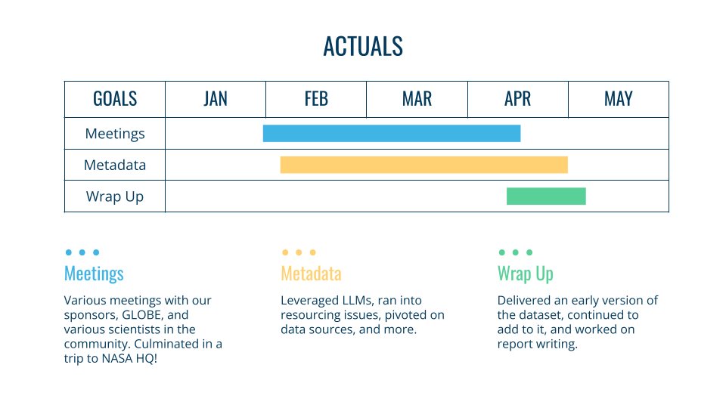

# Chapter IV: Analysis

# 

## Overview of the Data

Given the nature of this project, with our team focused on metadata acquisition and another on modeling, our analytics strategy emphasized determining which data sources were most valuable to augment the GLOBE dataset, determining methods or sources to extract additional information, and continuously iterating based on feedback from subject-matter experts, including scientists affiliated with NASA.

As discussed in Chapter 3, our data spans multiple sources and decades but the primary focus on this project was to add to the GLOBE transparency dataset, which contains over 160k in-situ observations since GLOBE’s formation in 1995. In this chapter, we explore the various sources utilized, tools developed, and processes followed to create our enhanced dataset. We also explore if citizen scientist data, utilizing our dataset can be used in a supportive manner for scientific research.

## Water Body Classification

With over 60% of observations lacking consistent or interpretable metadata describing the surrounding water body this was a major challenge where the initial path was not apparent. Our initial strategy for classifying water bodies within the GLOBE dataset centered on deploying a Vision Transformer (ViT) model. The plan involved sourcing satellite imagery corresponding to each observation's geolocation and training the ViT model to recognize and categorize various water body types. However, the absence of pre-existing images in the dataset required a large manual effort to procure and label an extensive image dataset, rendering this approach resource-intensive and time-consuming.

In exploring alternative solutions, we considered leveraging a large language model (LLM) to assist in generating a training dataset for the ViT model. This involved using the LLM to infer water body types based on available metadata, thereby creating labeled data for the vision model. Upon evaluating the LLM-generated labels, we observed a high degree of accuracy and consistency, prompting a shift in our approach. Our LLM's performance surpassed our expectations, leading us to adopt it as the primary model for water body classification, effectively replacing the need for a separate vision-based model.

This strategic shift not only streamlined our workflow by eliminating the need for extensive image data collection and labeling but also leveraged the LLM's strengths in natural language understanding and contextual reasoning. The result was a more efficient and effective classification process, aligning closely with expert human judgment and significantly enhancing the GLOBE dataset's utility for scientific research.

To enhance the LLM's domain-specific reasoning, we conditioned it to emulate the expertise of Dr. Ivona Cetinić, a distinguished NASA oceanographer and one of our project's sponsors. Dr. Cetinić has been cited over 3,800 times in scientific literature and has contributed to various documentaries. By integrating Dr. Cetinić's knowledge into the model, the model adopted the name IvonaBot**.**

From there it was straightforward to label all 28,175 observations which labeled 92% and yielded some instances labeled as "Unknown". The Unknown label was a result of the model's free-text answers that did not match any of our keyword strategy. To address this, we iteratively refined the prompts and reprocessed these instances, successfully reducing the number of unclassified records. This iterative approach enhanced the model's ability to handle edge cases and improved overall classification accuracy.

After iterative refinement, all "unknown" cases were resolved, resulting in the following distribution. The final label set shows Marsh as the dominant class (45%), followed by Rivers/Streams (36%). The water-body classification distribution is practical based on the available resources by geolocation.

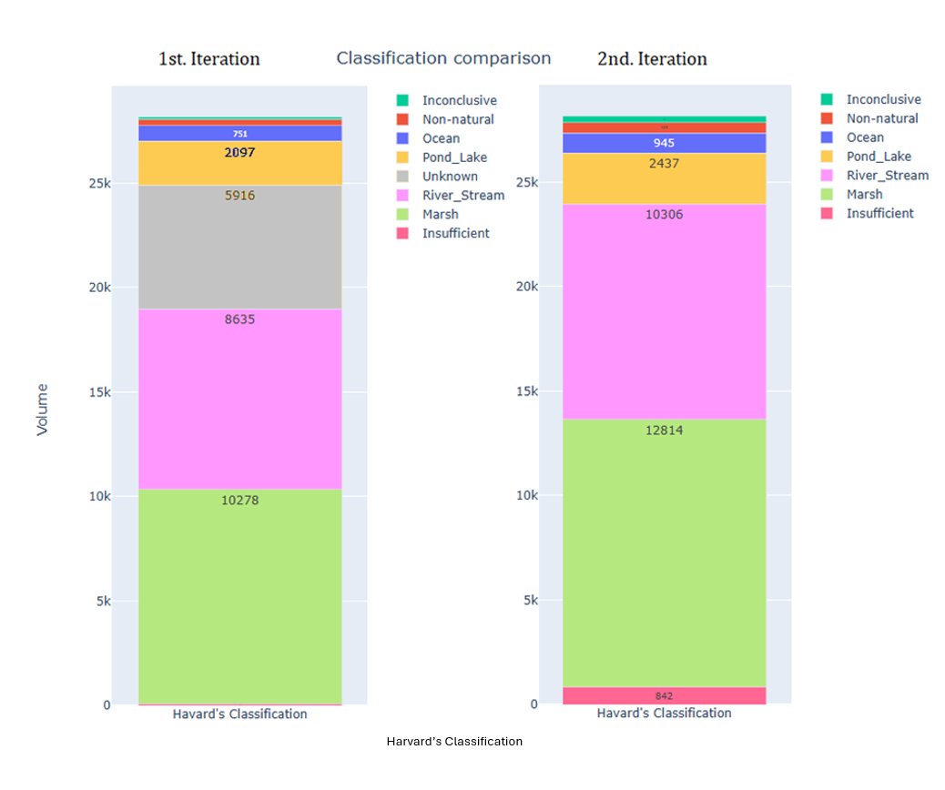

**Chart 1**: Initial classification Distribution (Including "Unknown" labels)

**Chart 2:** Final Classification Distribution (post-refinement with all observations classified into the five primary categories)

### Model Quality Assessment

To evaluate IvonaBot classification reasoning, we conducted a cross-tabulation analysis comparing the newly assigned water body labels with the existing "water_body_source" metadata in the GLOBE dataset. This legacy field comprises 13 distinct categories, including "stream," "lake," "reservoir," "wetland," "irrigation canal," and "ocean." It was Dr. Cetinić recommendation to simplify the 13 categories into the five primary classes. We aimed to assess the degree of alignment between the LLM's outputs and historical data entries.

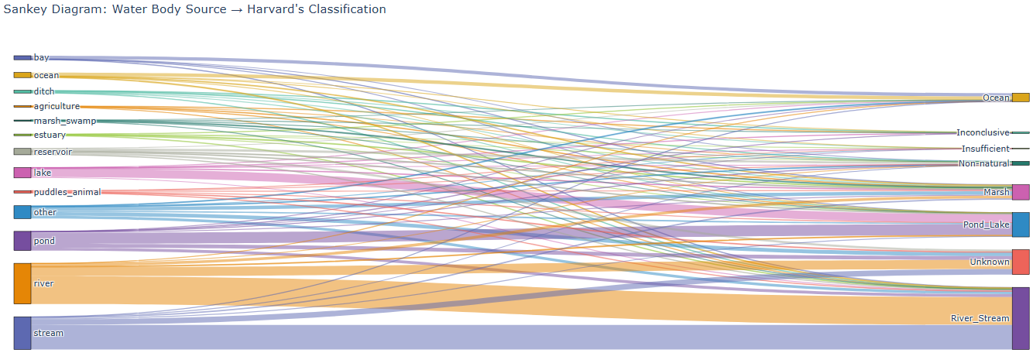

**Chart**: Shows a Sankey Diagram of the reclassification mapping between the provided GLOBE site classifications and the modeled classifications.

#### Chi-Square Test of Independence

To statistically assess the association between the LLM's classifications and the legacy "water_body_source" categories, we performed a Chi-square test of independence. This test evaluates whether there is a significant association between two categorical variables. The rationale for this approach is that in a manual labeling effort a human analyst would heavily rely on the legacy water-body source labels.

Our analysis yielded a Chi-square statistic of 17,133.16 with 72 degrees of freedom and a p-value less than 0.001. These results indicate a statistically significant association between the two variables, suggesting that the LLM's classifications are not independent of the legacy metadata.

#### Cramér's V

To measure the strength of the association identified by the Chi-square test, we calculated Cramér's V, which is a measure of association between two nominal variables. The resulting value was 0.53, indicating a moderate to strong association between the LLM's classifications and the legacy "water_body_source" entries. This further supports the conclusion that the LLM's outputs are meaningfully aligned with historical data.

The cross-tabulation analysis, supported by the Chi-square test and Cramér's V, demonstrates that the LLM's classifications are statistically and practically consistent with the GLOBE dataset's existing metadata. This concordance validates the LLM's effectiveness in accurately classifying water bodies based on available data.

#### Manual Audit with Remote Sensing Imagery

A manual audit was conducted on a stratified sample of 3,000 observations, comparing satellite imagery of the observation locations with both the LLM's classifications and existing metadata. The audit revealed a high similarity relationship between the LLM's outputs and human assessments, even in instances with limited or vague data. This validation captures the model's effectiveness in accurately classifying water bodies based on available metadata.

### Limitations and Future Enhancements

While IvonaBot demonstrated robust performance, certain limitations were noted. The model's accuracy is contingent upon the quality and completeness of the input metadata. Instances with sparse or conflicting data posed challenges, requiring iterative refinements. Future enhancements could involve fine-tuning the LLM on domain-specific literature to bolster its contextual understanding. Additionally, integrating remote sensing data could further enhance classification accuracy, particularly in cases where metadata is limited.

#### 

## Water Distance Analysis

First we will evaluate the performance of the water extraction algorithm itself, beginning with imagery analysis, then proceed to aggregate results. Below are four examples chosen for their unique characteristics, which highlight the advantages and disadvantages of our approach.

First we present a sample site on the Kupa River in Croatia. The river, as it flows through the city of Karlovac, is mostly well defined, with embankments, as it winds through the city center. This produces a very clear image of the river in satellite imagery. The left hand picture below is the sample site as it appears in Google Maps, the middle picture is the same location in Google Maps satellite view, and the third is the water-extracted image from Sentinel-2. Water is shown in black and land shown in white. The blue dot in the right hand image represents the nearest water location from the sample site. The sample site is ordinarily labeled with a red dot, but in this case the sample site is directly on water and the red dot is hidden under the blue dot, meaning the distance to water is 0m. Water extraction from satellite imagery generally performs well for broad rivers with clear shorelines.

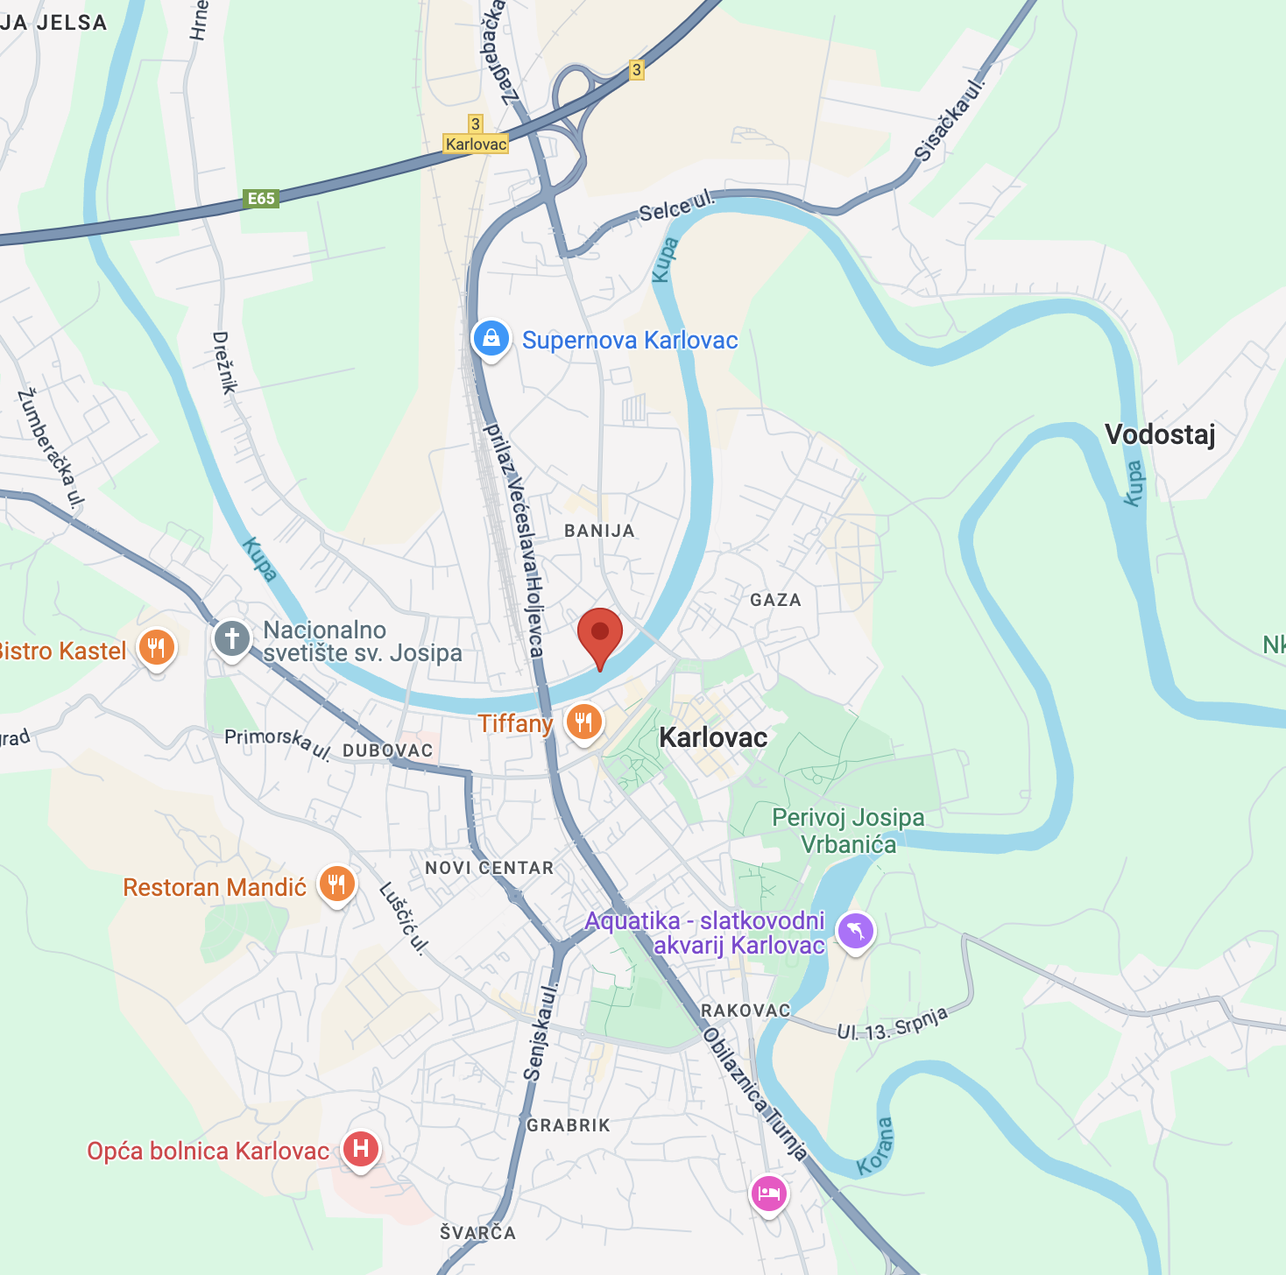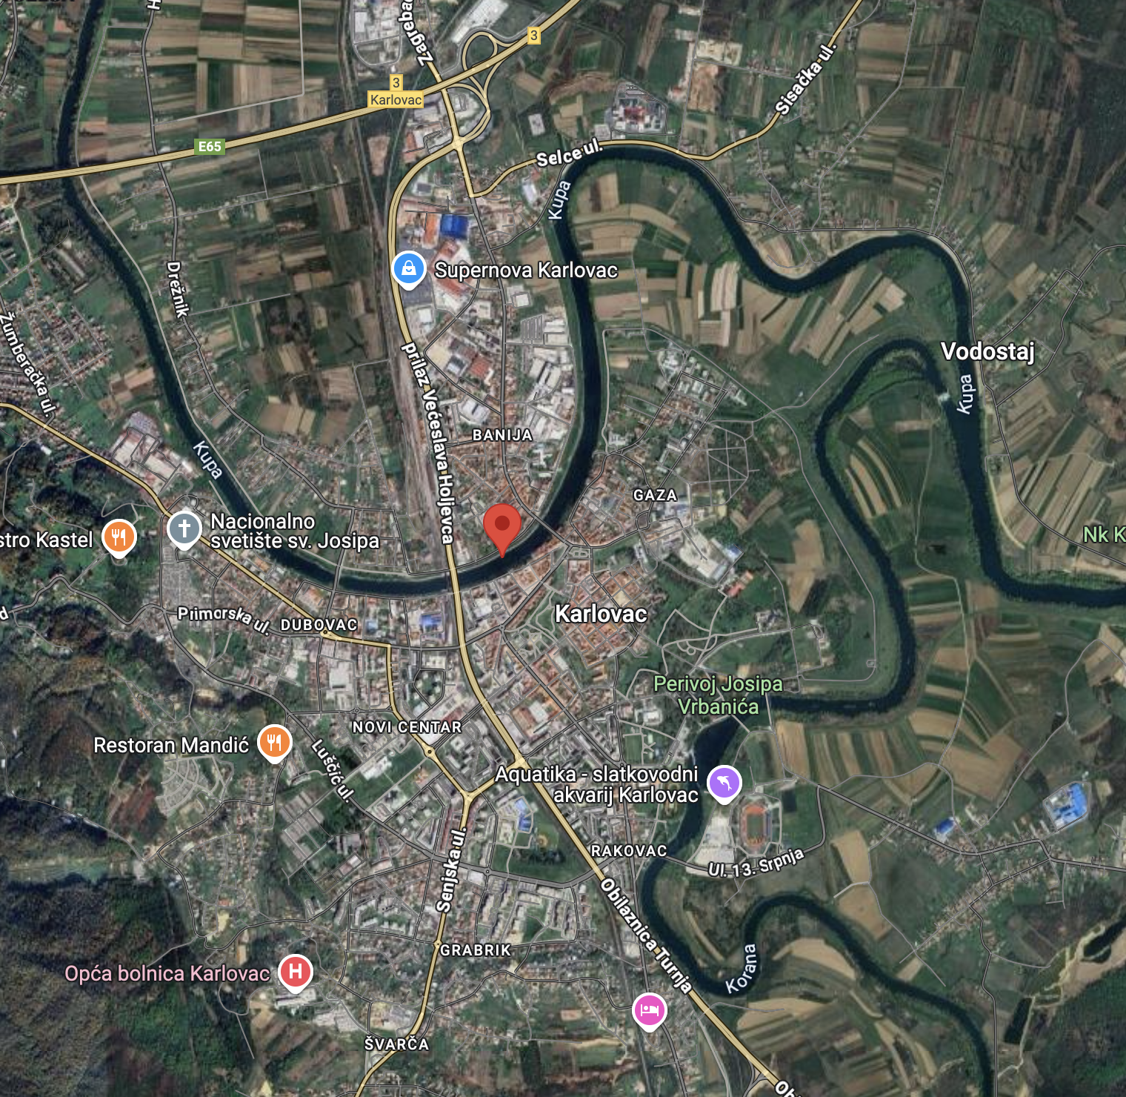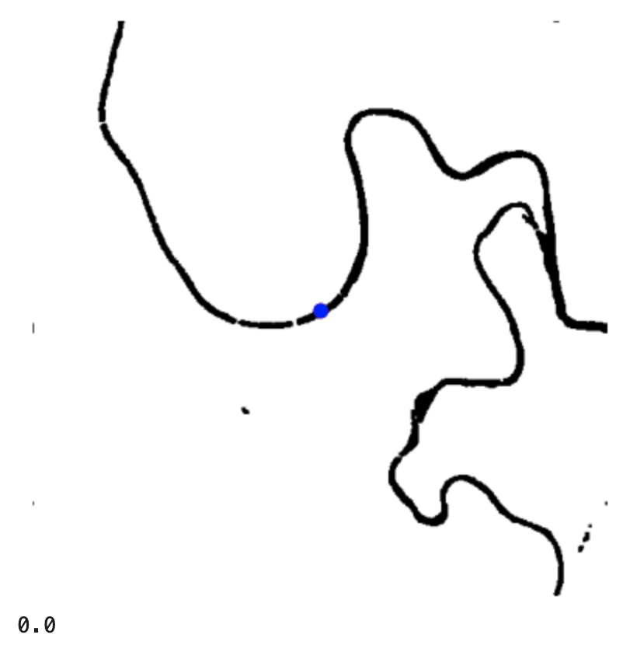

This procedure also performs well for ponds, lakes, and other contained water bodies, with some caveats. For example, below is a sample site at Kelly Park East in Merritt Island, Florida. Again, in this example, the water extraction algorithm seems to locate most water bodies, including rivers, sloughs, lakes and marshes. However, some narrow waterways are not visible, especially if they are algae covered.

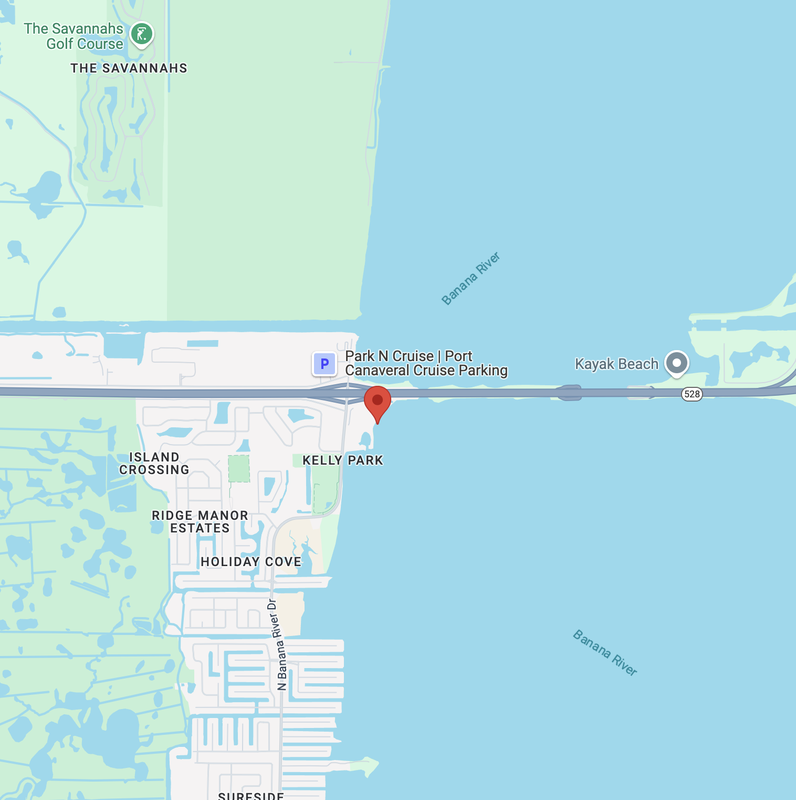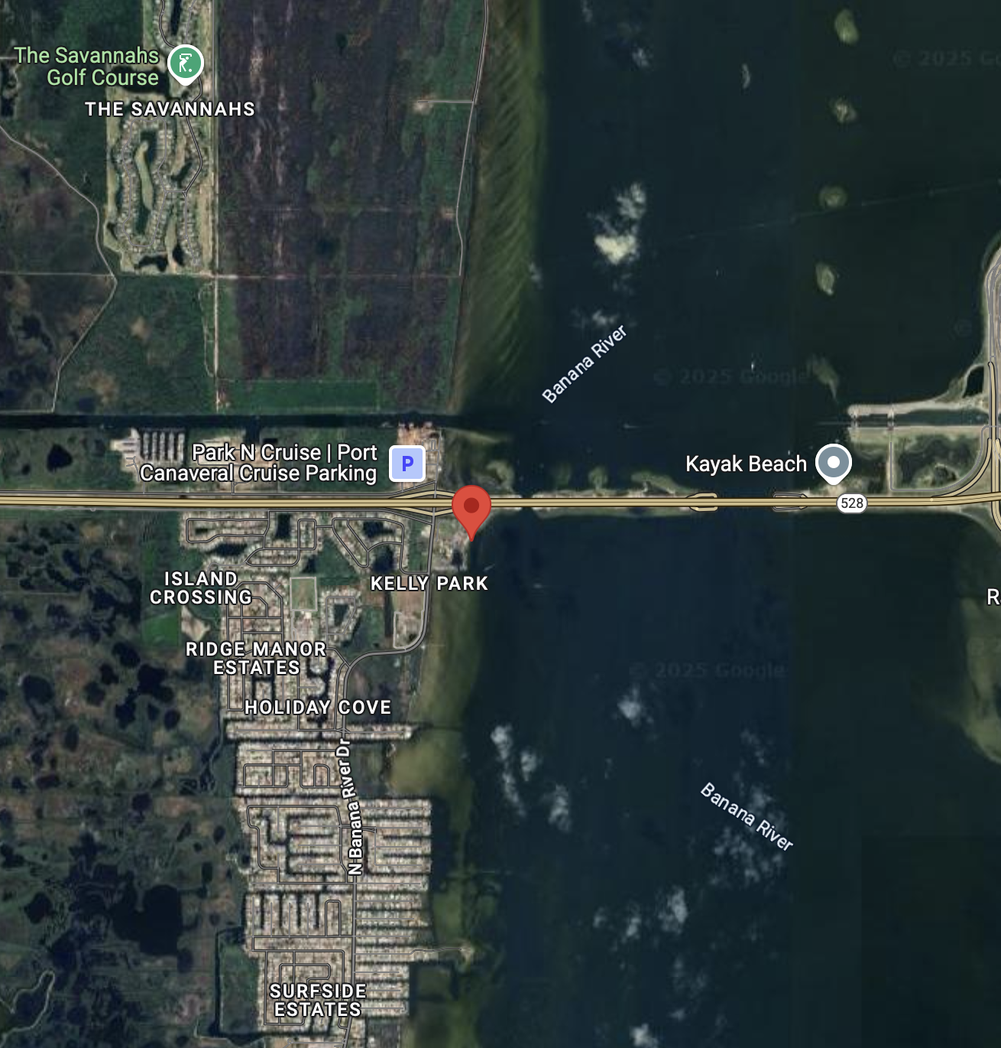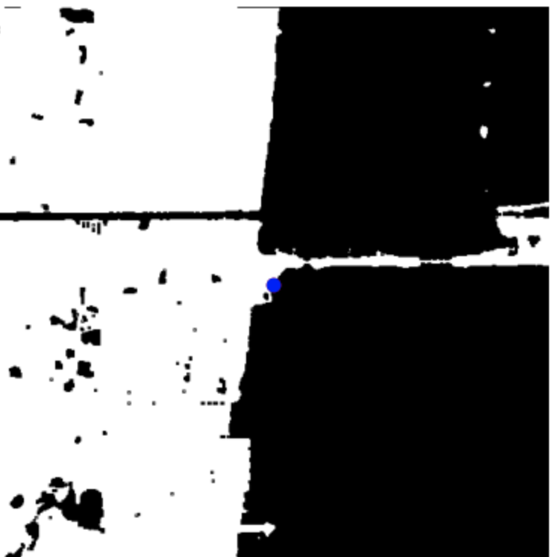

To further illustrate this issue, below is a marsh that is immediately adjacent to the Willamette River in Eugene, Oregon called Delta Ponds. The water extraction process easily identifies the Willamette River as it travels through Eugene, but the marsh where the sample was taken from seems rather sparse. In fact, the sample site is calculated as 125m away from water since the location is just slightly on land and the shoreline near the sample site is covered in algae and other greenery, making it difficult to isolate and label using the NDWI technique.

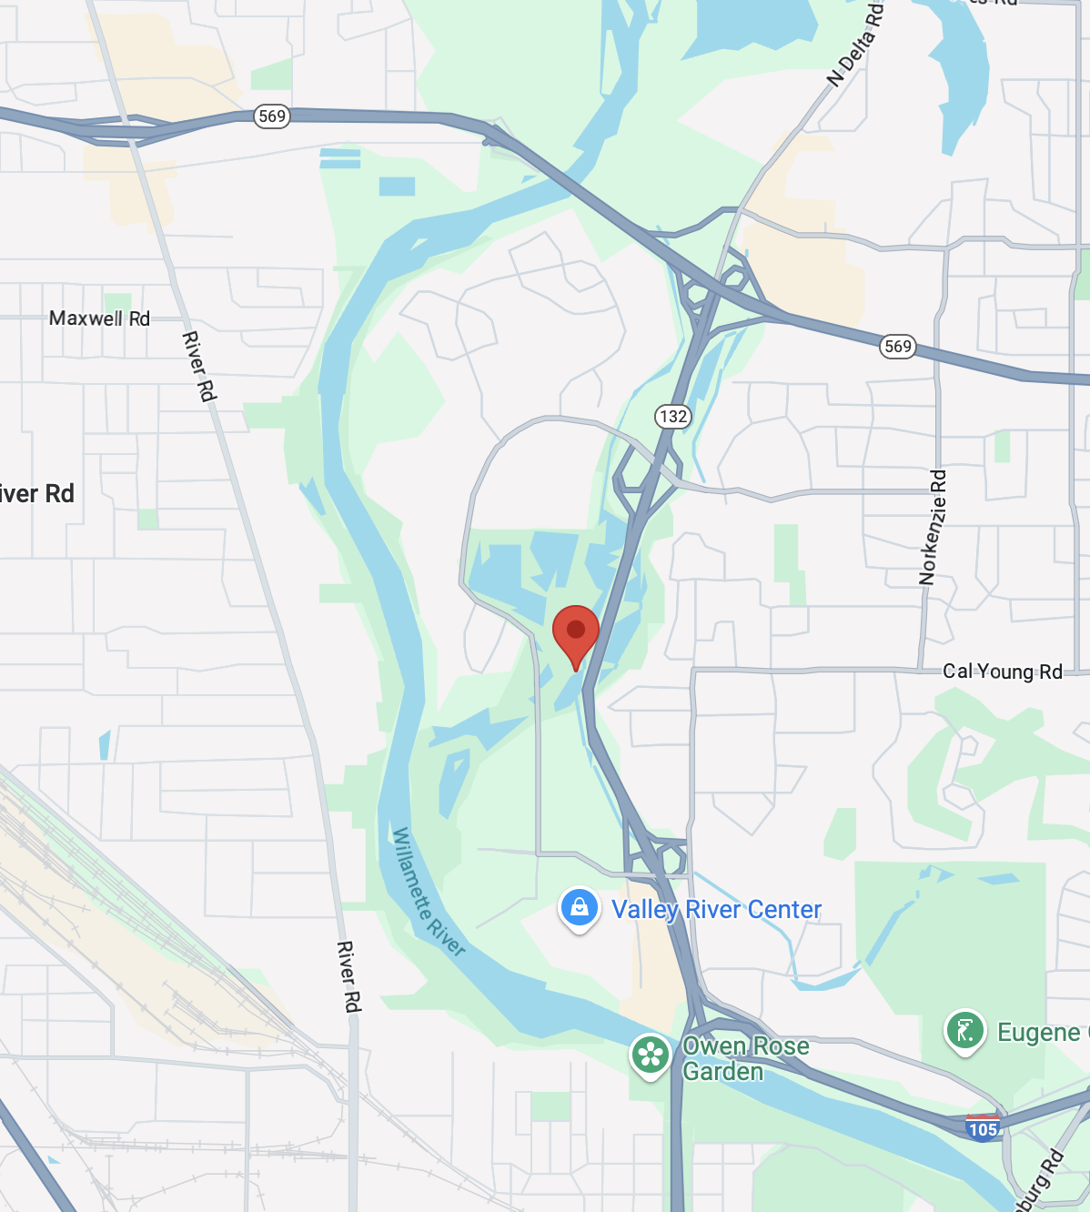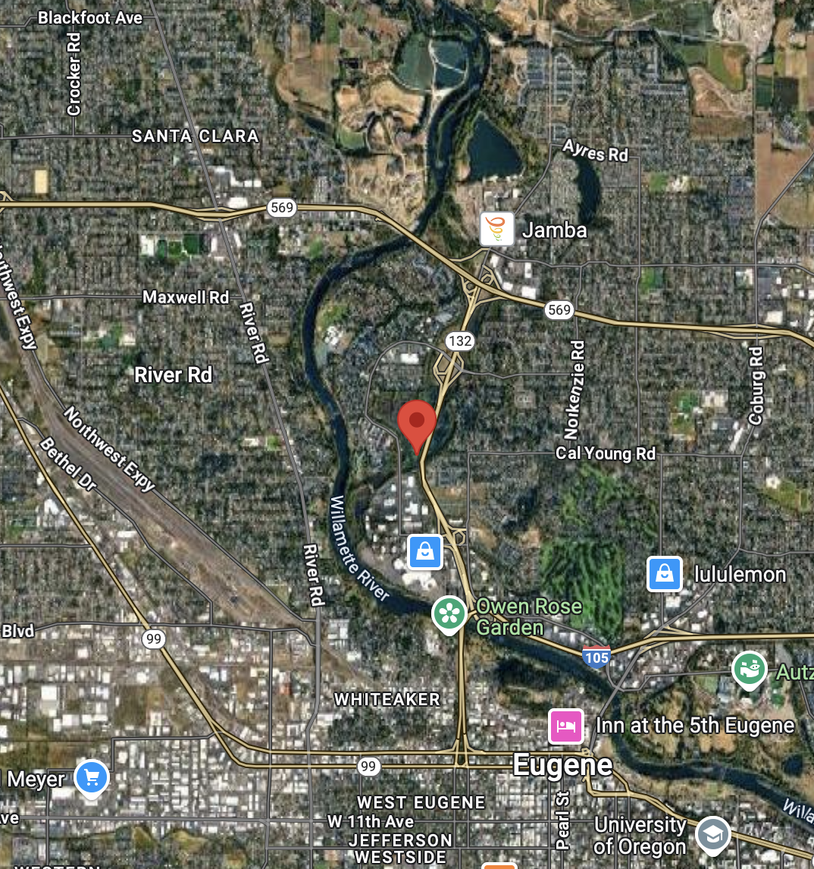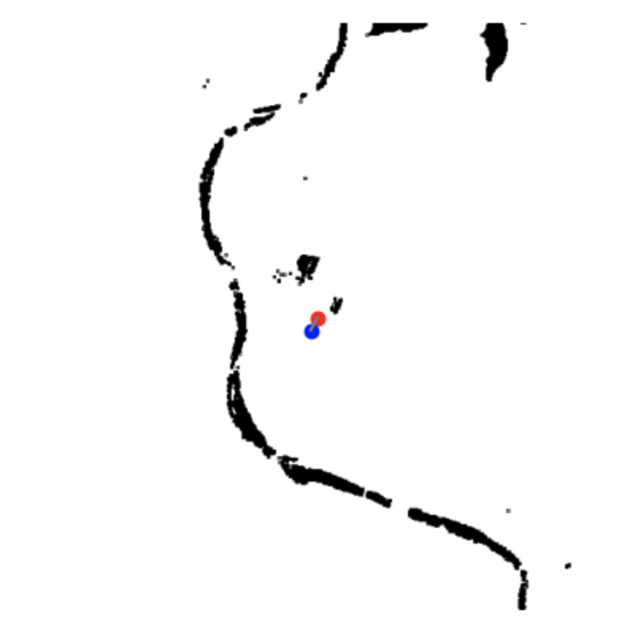

Finally, sample sites that are near buildings or large trees may present as false positive water bodies that are associated with shadows created from those structures. Below is a sample site on Lake Merritt in Oakland, California. Notice just to the west of the sample site there is some scattering of black dots (presumed water); however, this noise is due to the presence of tall buildings in that location, since this is the downtown urban area. This is a known issue with the NDWI process, as documented in our Literature Review above.

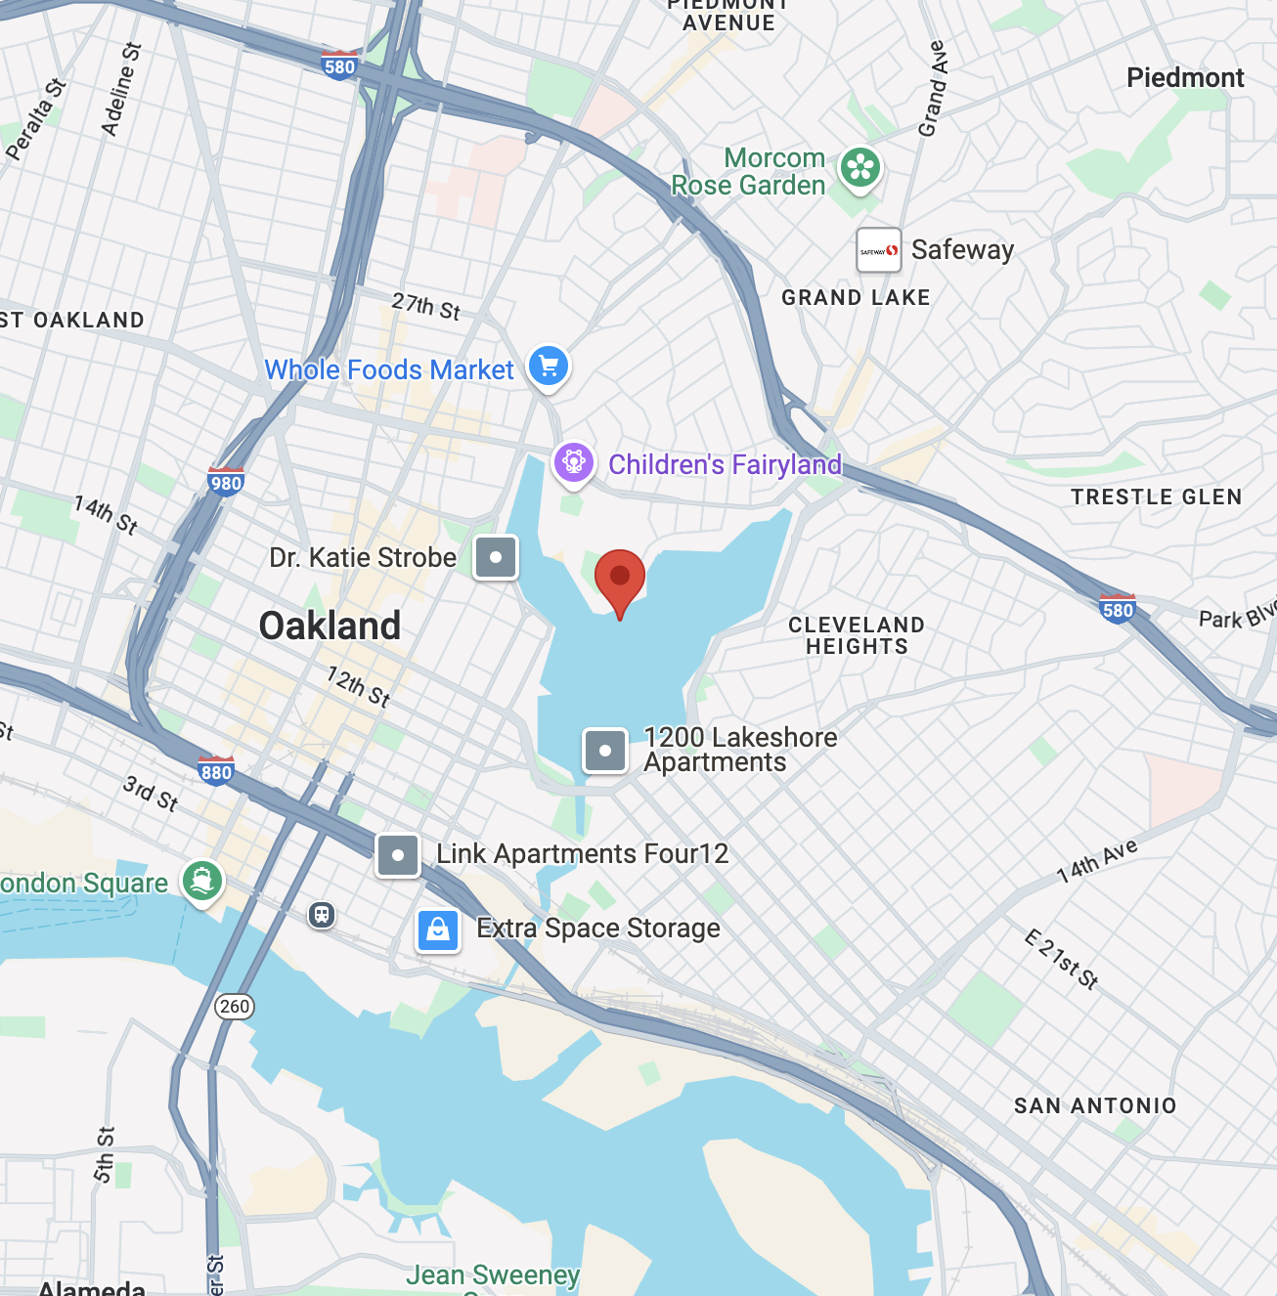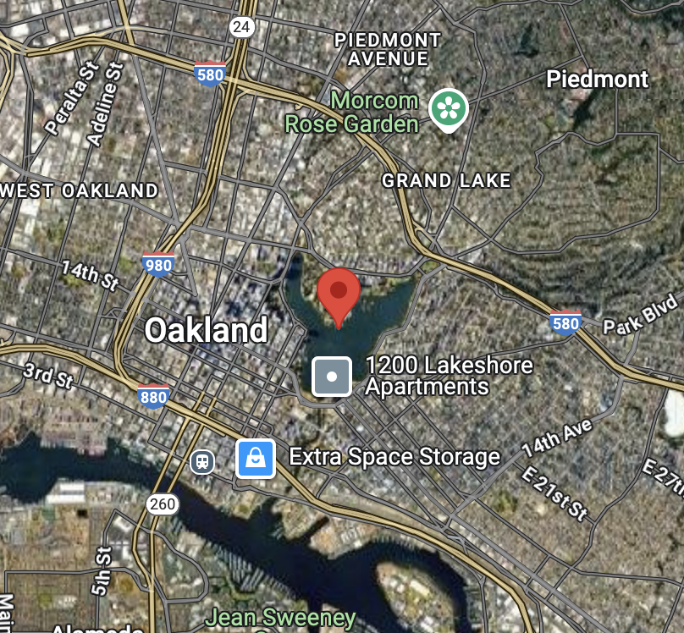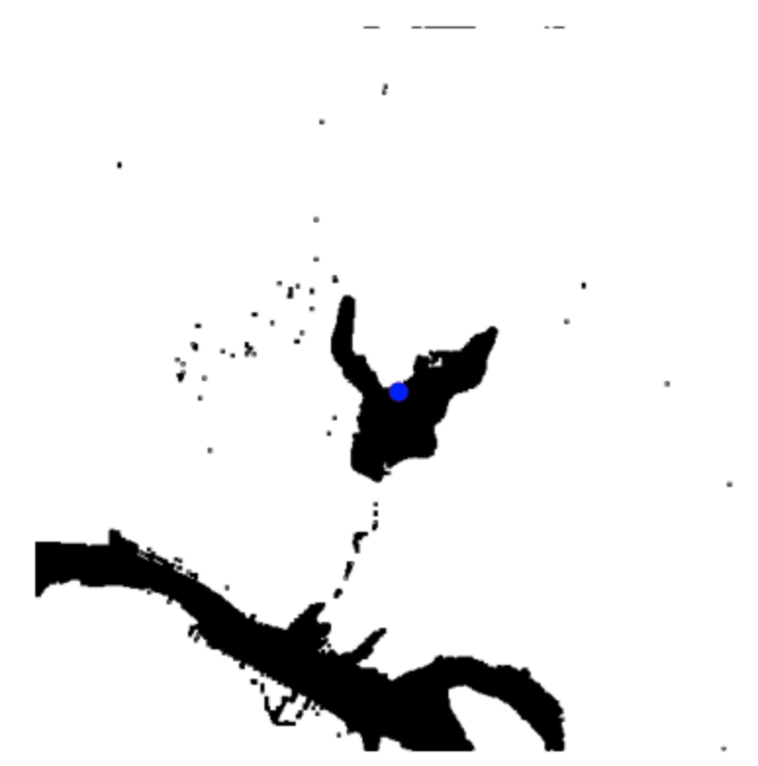

Next we investigated situations in which satellite imagery was used to locate water bodies that were closer to the sample site than OpenStreetMap. This is an indicator of regional coverage gaps in OpenStreetMap, but we acknowledge biases exist in this method of evaluation. The first bias is that the GLOBE sample sites themselves are not uniformly geographically distributed. Second, as discussed above, our water extraction methodologies create some false positives, such as building and tree shadow. Therefore, not every situation where satellite imagery uncovers water is a true positive indication of the presence of water. Even so, there are some regional differences when breaking out this metric by country. Below is a chart showing the percentage of found water that was identified through OpenStreetMap vs satellite imagery.

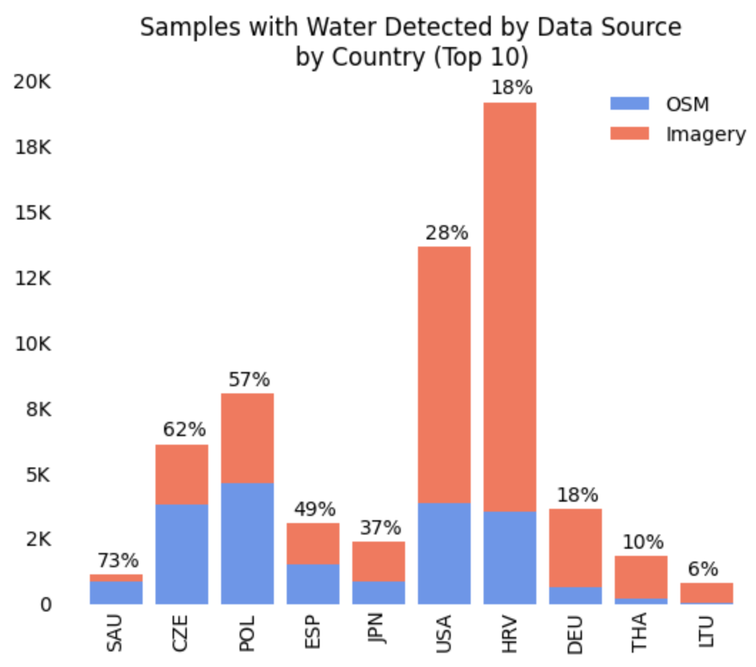

Saudi Arabia appears to have the highest percentage of water-detected samples that come from OpenStreetMap (73%). This may be because there are so few Saudi Arabian samples where water is detected, and those samples are near obvious (and well-mapped) water bodies. Eastern Europe (such as the Czech Republic and Poland) have relatively high percentages of water found using OpenStreetMap (62% and 57%, respectively). Interestingly, the United States and Croatia, which are two large contributors of sites with detectable water, have a relatively low percentage of sites where water was found using OpenStreetMap (28% and 18%, respectively).

When viewing the aggregate data, our results show that distance from water, or simply the presence of visible water within approximately 1 km of the sample site, is highly skewed by region and water type. First we will present the overall distribution of samples by their distance from water. Below is the histogram of distance from water. Note that values of 1000 meters signify that water was not found within 1 km of the sample site. Nearly 60% of samples were found to not have water within a 1 km bounding box of the sample site.

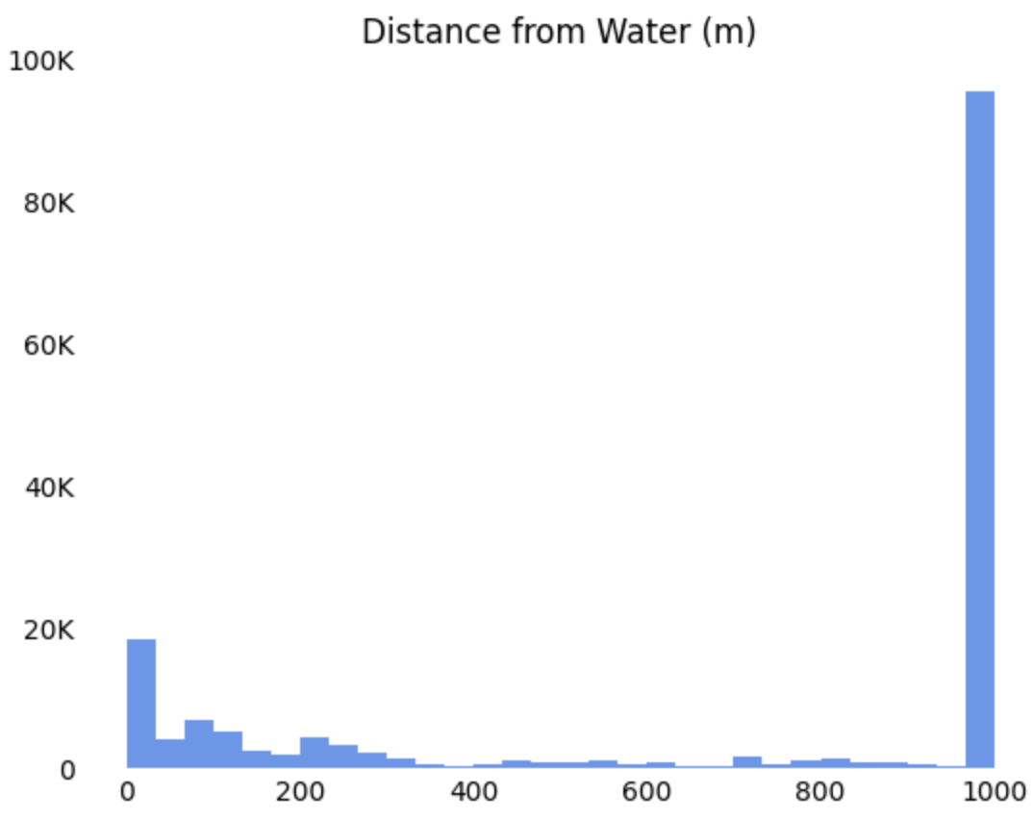

Water is generally found within 300m of the sample site, otherwise it is unlikely to find water within 1km. Recall the methodology described above where OpenStreetMaps is queried first, before satellite imagery, and if the site is found to be within 300m then that result was deemed acceptable and satellite imagery was not queried to meet resource constraints. This procedure may be the reason for the density of values under 300m. However, when water was found at or near a sample collection site, most often this was due to imagery verification. Below is the distribution of samples by distance from water by data source. “None” denotes that water was not found near the site.

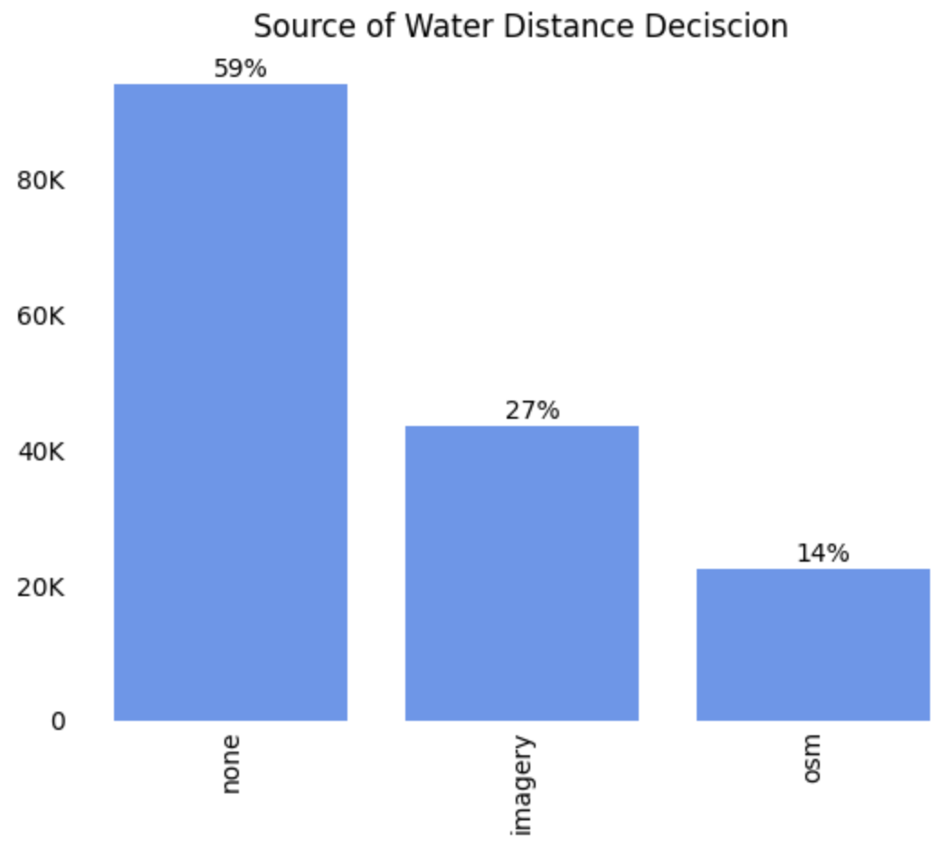

Interestingly, the presence of water was verified using satellite imagery twice as often as OpenStreetMap. However, again note that 59% of samples were found to not be near water. Below is a breakdown of whether water was detected near the site shown by water body category type.

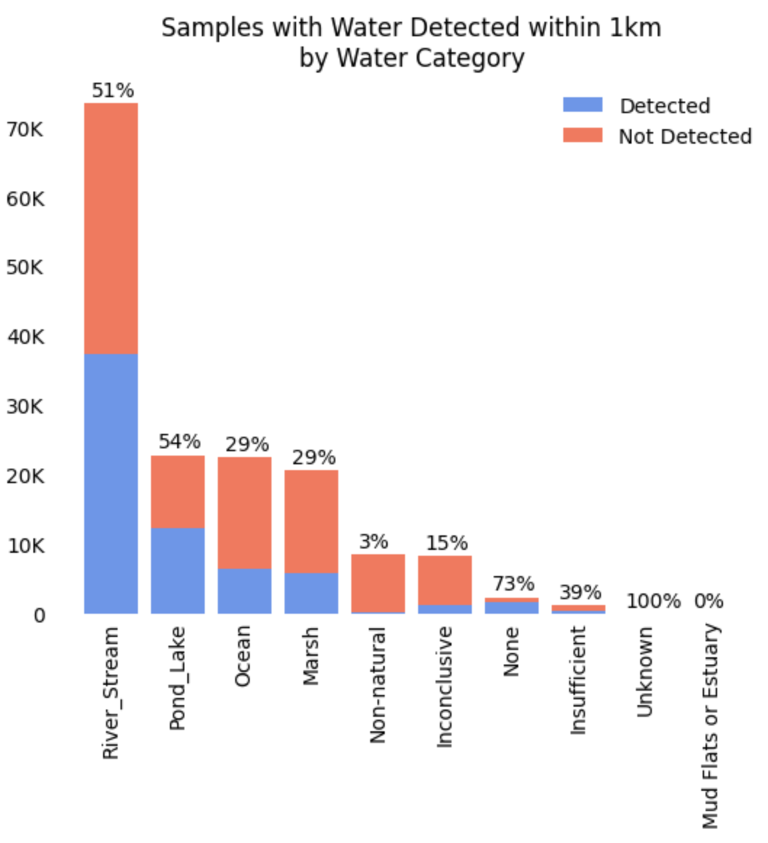

Most samples are taken from rivers or streams, which are near water 51% of the time. Ponds and lakes show a similar percentage of samples where water was detected. Interestingly, ocean and marshes have a much lower percentage of samples where water was detected. As noted above, OpenStreetMap has limited oceanic coverage within our workflow constraints. Marshes could be less common in the OpenStreetMap databases since they have less clear shoreline boundaries, and perhaps are not permanent water bodies. Finally, only 3% of non-natural water bodies, which according to protocol should not be included in the GLOBE water transparency dataset, are near visible water bodies. It is possible that these non-natural water bodies could be tubs placed inside classrooms to draw samples from or fountains that sit under tree cover (and are thus not visible from satellites). Both OpenStreetMap and satellite imagery have advantages and disadvantages regarding water detection, as evidenced by the correlation between water detection and watery body type.

Similarly, there are strong correlations between water detection and country. Below is a breakdown of the percent of samples where water was detected by country. It is apparent that only 2% of samples that come from Saudi Arabia have water detected nearby. Note that this could potentially be due to lack of OpenStreetMap coverage or clear satellite data.

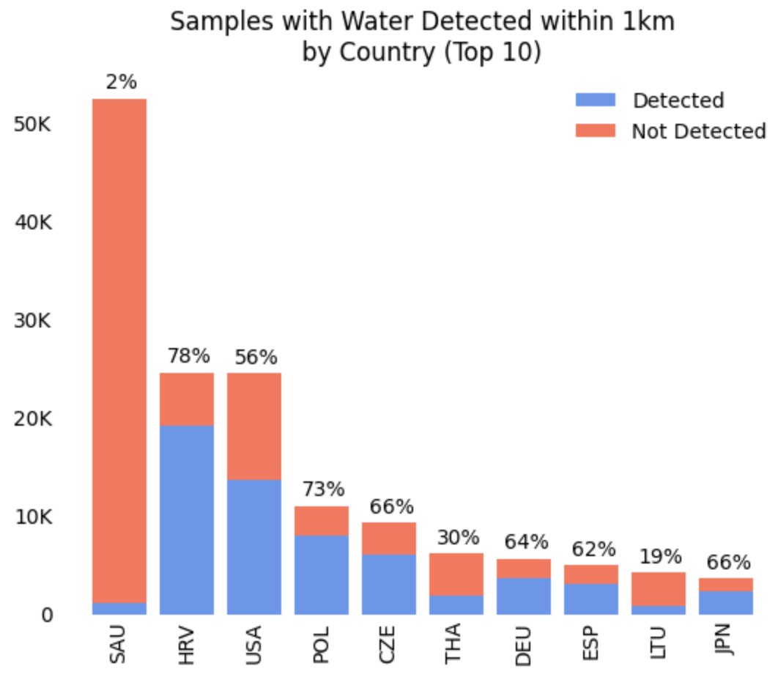

The next two countries that contribute the most samples are Croatia and the United States. Croatia is the largest contributor of samples where water was detected, contributing 29% of samples where water was detected. Most nations, within the top 10 countries by total samples contributed, have between 60-80% of their samples located near verified water bodies.

In summary, samples where water is detected tend to be located in Europe and taken from rivers, streams, ponds, and lakes. There are some situations in which it seems as though the water sampling protocols are not being followed, for example, in the case of sampling from non-natural water bodies, where follow-up with the client organizations may prove valuable.

## Transparency Tube Length Estimate Analysis

We ran both the algorithmic and MLE models over samples grouped in two ways: by site and by country. When samples are grouped by site, all samples for a particular site are time-ordered and processed through each model. Since many sites only have a few samples (providing less prior information), we also grouped samples by country and processed them in the same manner. The assumption in this case was that tubes used for a particular country were likely to be similar even if they were not used at the same site.

The results show striking similarity between the sites and country approaches, and also between the two modeling methodologies. Below are confusion matrices showing the agreement between the Algorithm and MLE methods by sites and also by countries. Note how both methods agree that the two most common tube lengths are 60cm and 120cm. The MLE model tends to favor longer tube lengths vs the algorithmic method. Clearly, when they disagree the MLE method exclusively estimates a longer tube vs the algorithmic method. Overall, the two methods agree 96% of the time when run by sites and 93% of the time when run by countries (these statistics disregard N/A samples, which show 100% agreement).

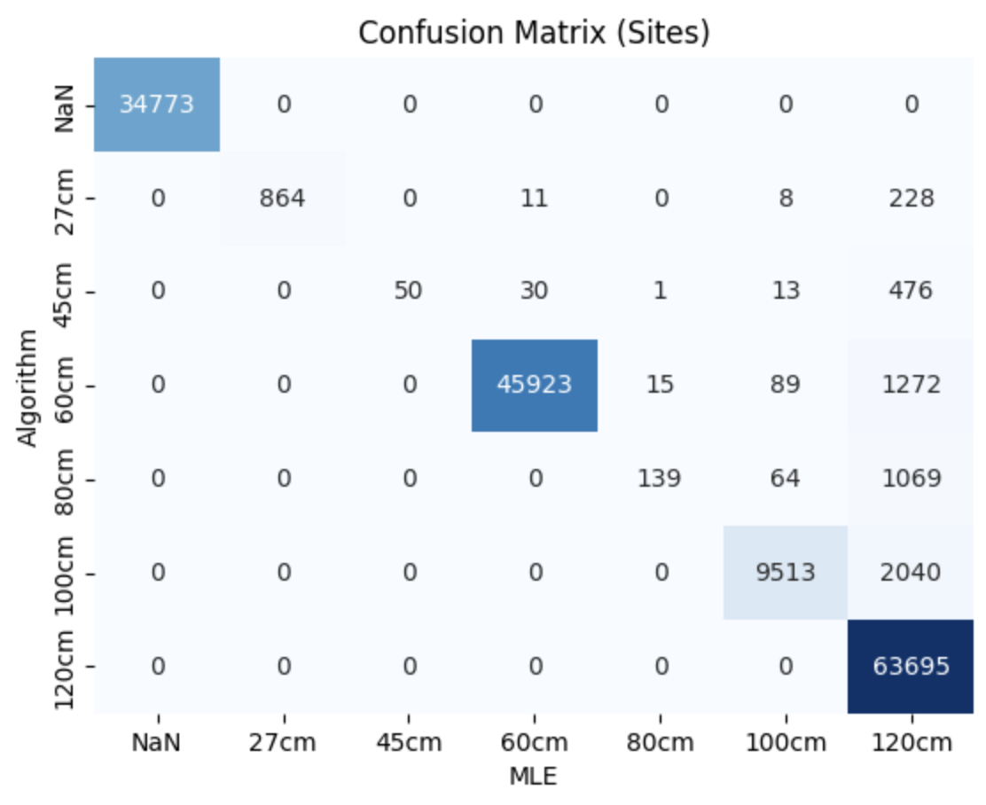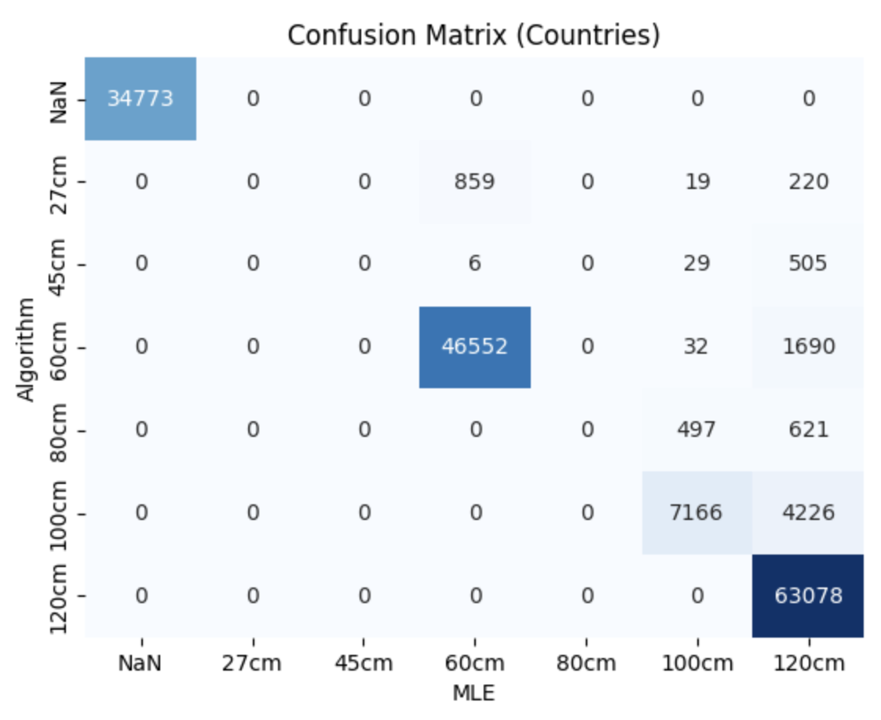

When focusing on the algorithm run by sample site (charts below), we notice that most often it determines the tube length according to the exact length of the measurement matching a known tube length (44% of samples). The second most common case is the algorithm determining the tube length by taking the mode of previous tube measurements that matched common tube length exactly, since this is most likely a saturated measurement (27% of samples). The fourth most likely scenario is “Longest common length”, which refers to measurements that are longer than 100cm but less than 120cm, in which case the only possible tube length can be 120cm (5% of samples).

Note that the first sample in a site or a country is considered 120cm, which is an arbitrary measurement but also guarantees that the sample is shorter than the estimated tube length (since 120cm is the max allowable tube length). This is labeled as “First sample, assume max”. In situations where the tube length is <100cm, but also longer than the mode, we take the next largest available tube length, and this occurs in a small number of cases labeled “Long enough tube length”.

Note that “Depth is zero” refers to N/A samples, and these samples are ignored (estimated tube length is set to 0). Also, measurements that are listed as “Too long” below are considered invalid since they are too long for any of the known tube lengths (invalid samples comprise 22% of samples).

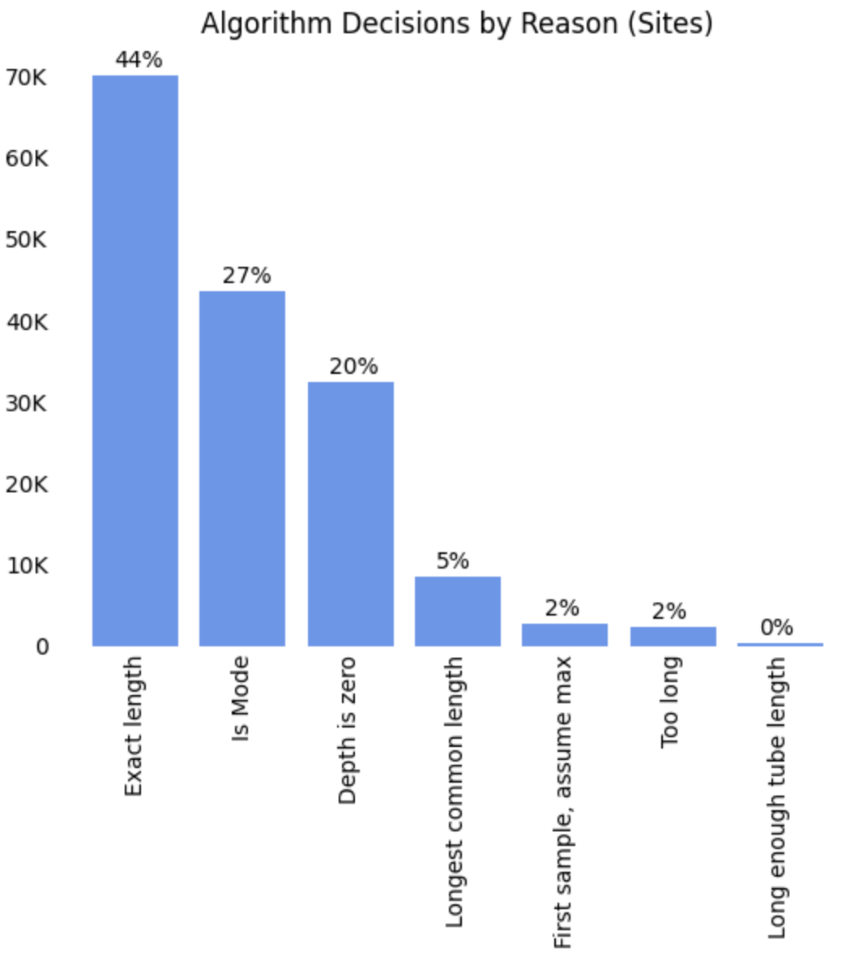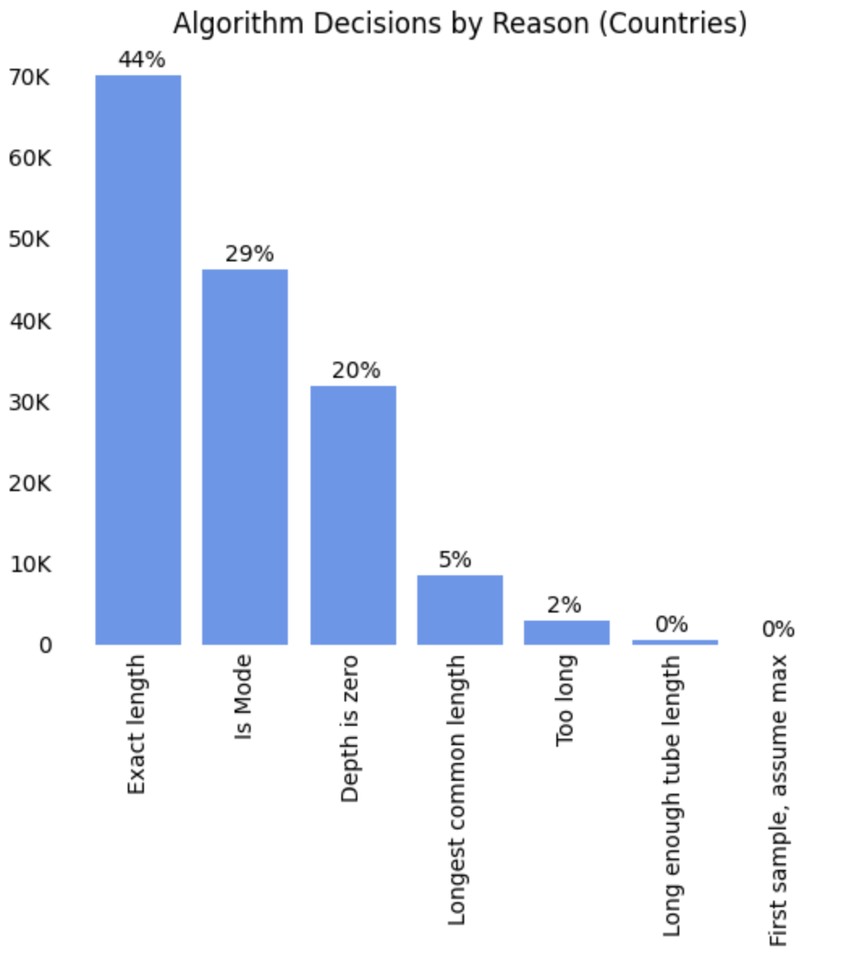

Additionally, we see estimated tube length varies by country. For example, below is the estimated tube length over time (i.e. using time-ordered observations) using the MLE model. As the samples are processed through the model it becomes clear that in the United States the dominant tube length is a 120cm tube, while in Saudi Arabia it is a 60cm tube. If tube lengths vary dramatically by country then data comparisons between countries could be biased since one country’s instrumentation was less sensitive. Regional variations in instrumentation may prove to be valuable insights for further analysis.

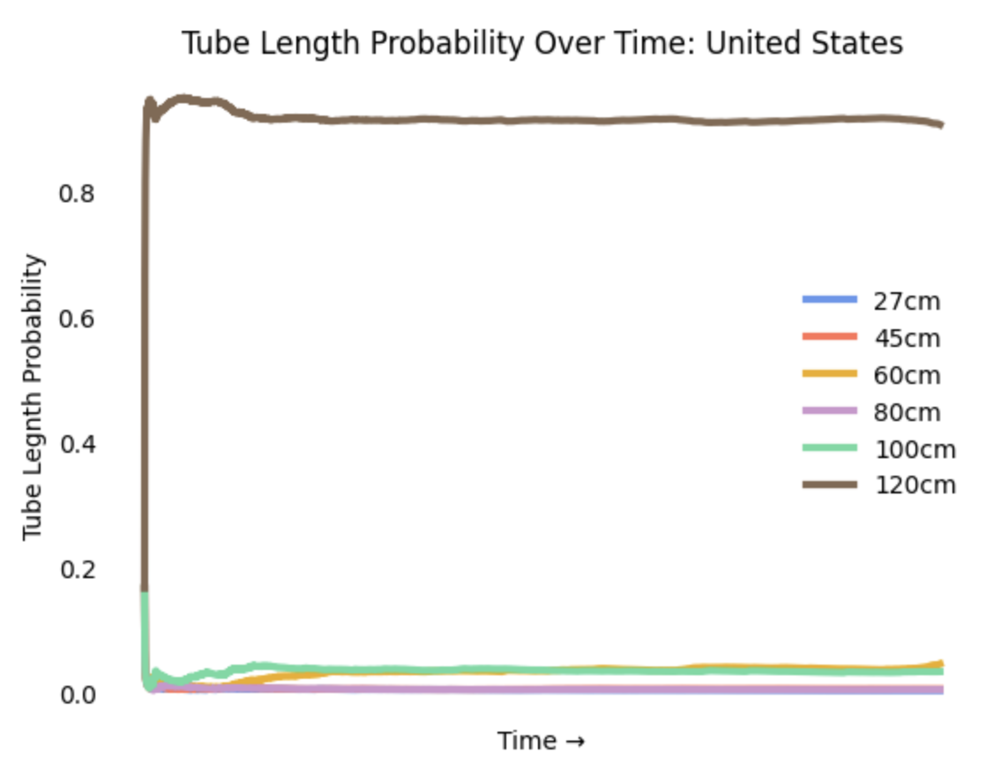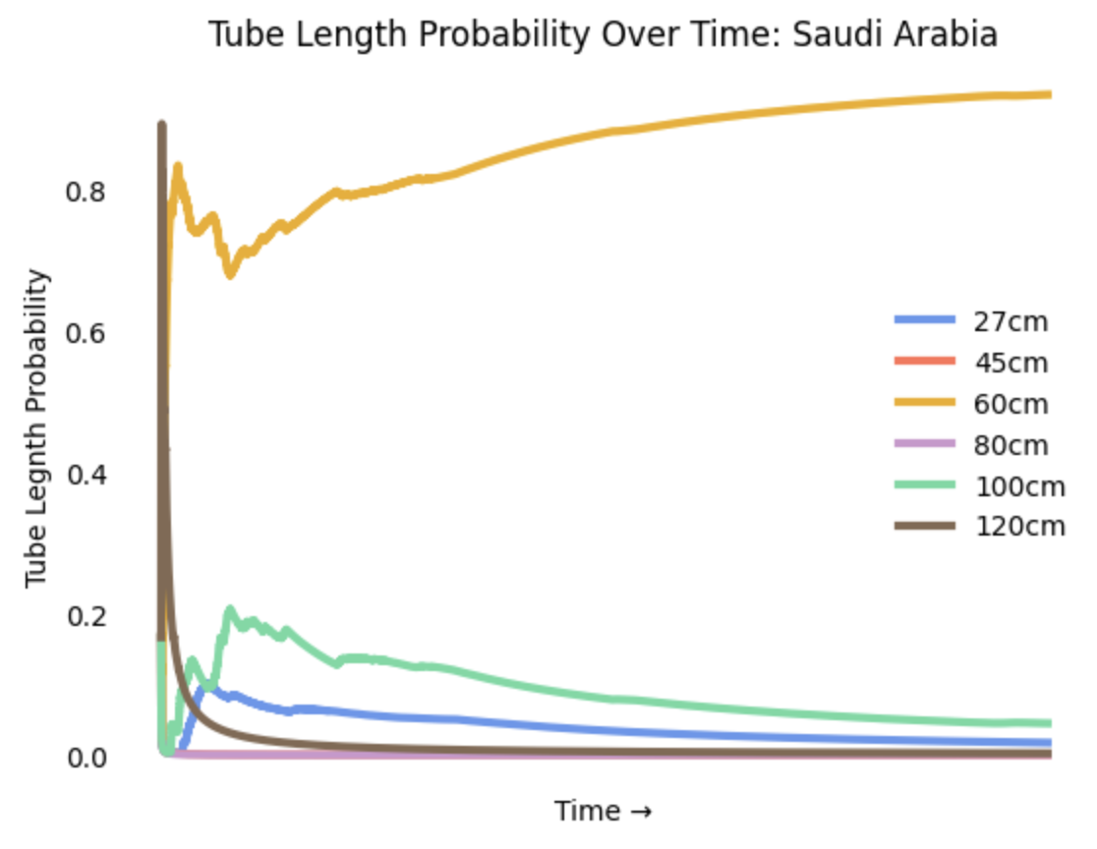

It is evident when exploring the data that Saudi Arabia has contributed a large number of observations that are exact 60cm measurements (likely saturated tube depths).

Finally, we present histograms of the normalized depth index for each modeling method and grouping procedure. All four combinations produce similar results, but there are some subtle differences, which highlight the benefits and drawbacks of each approach.

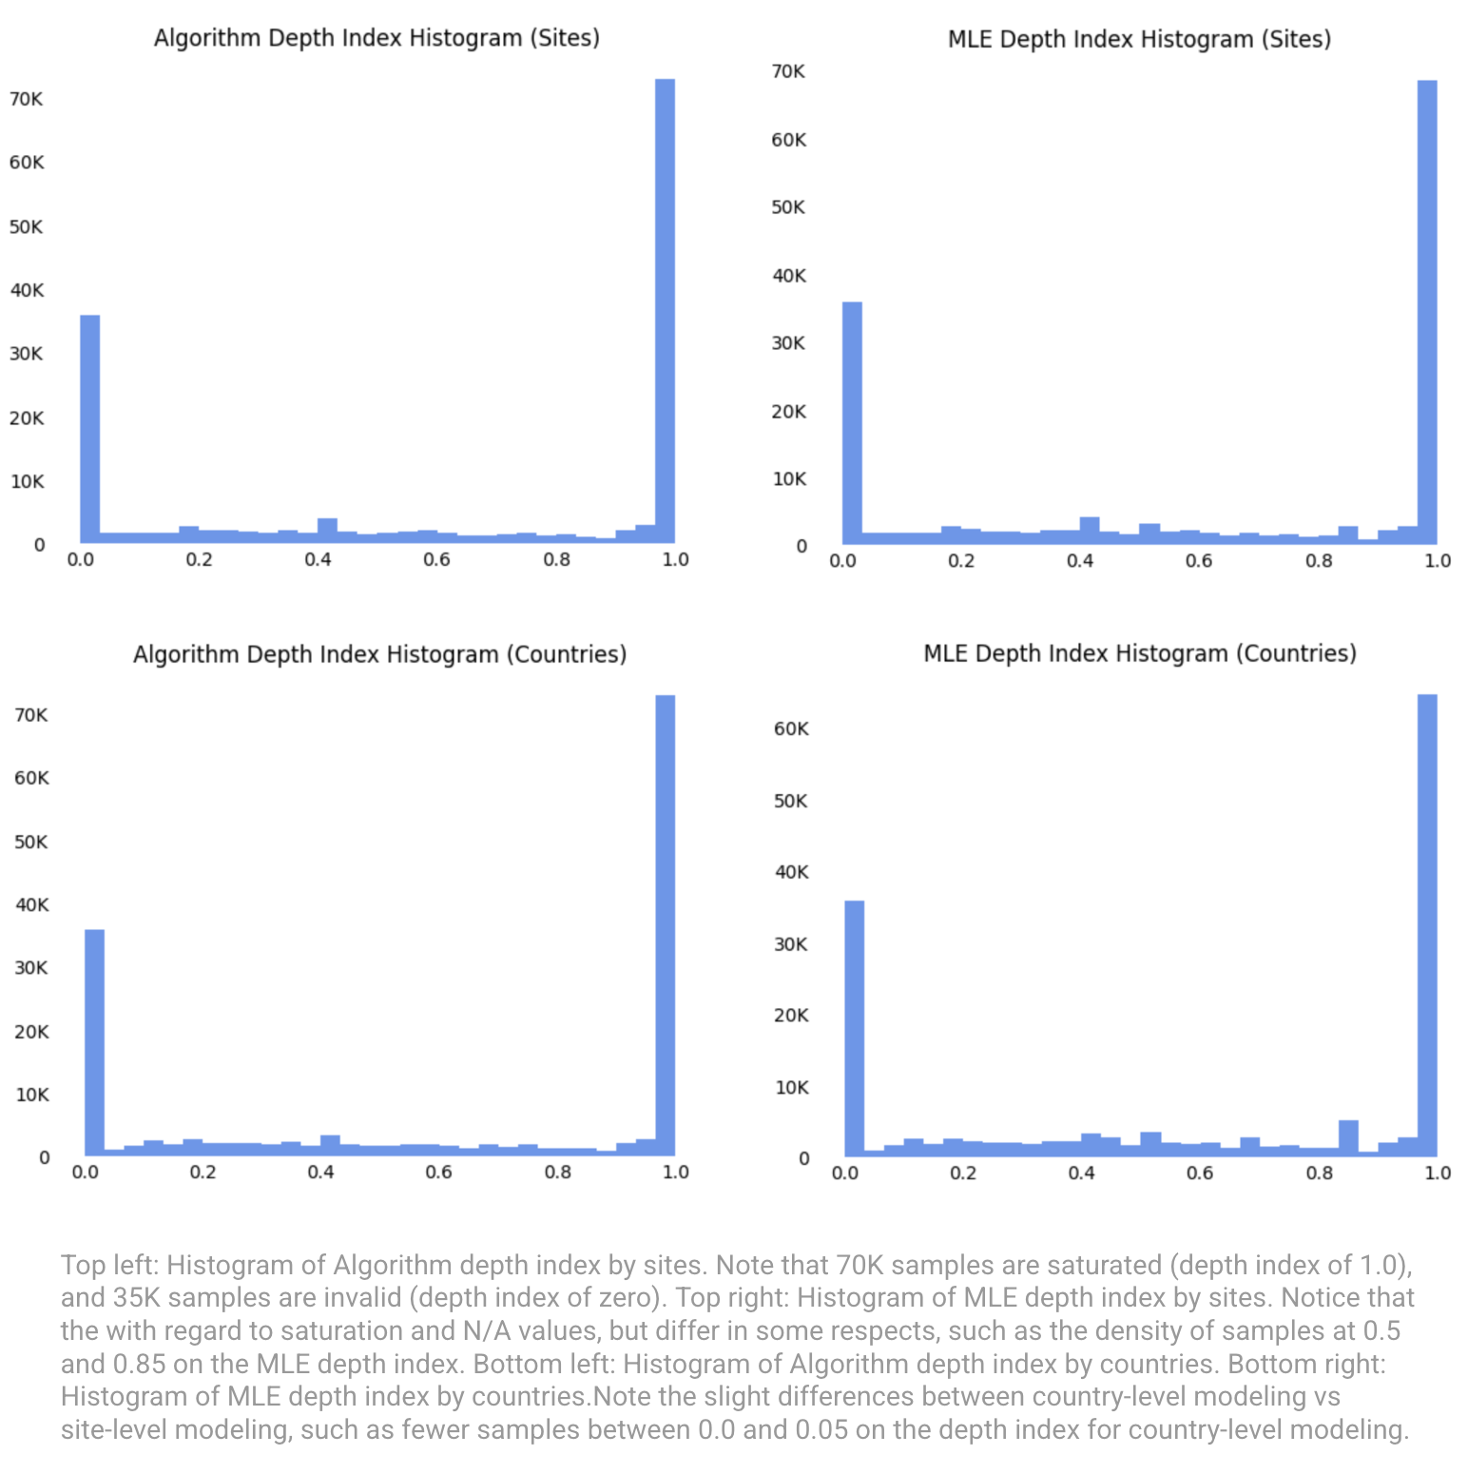

Notice that the models all generally identify the roughly 70K saturated samples, and also the 35K N/A samples marked as 0 (0 is an invalid depth index value). Regarding non-saturated measurements, the MLE model seems to produce more peaks at specific values, which would be indicative of errors, meaning they are actually saturated values of unknown tube lengths or simply misclassified. When grouping observations by country there are fewer depth indices close to zero, meaning that the model does not incorrectly predict that the sample came from an excessively long tube. This is because grouping by country often allows new sites within the same country to be pre-calibrated with prior information.

Overall, both the algorithmic and MLE methods have similar performance since their results align. The models are able to utilize basic information gleaned from the data to make their predictions, specifically the large set of samples that are presumed to be at saturation depth.

## Depth Analysis

Depth data was intended to help provide contextualization for the transparency readings. By providing corresponding bathymetric information we in theory could back into providing methods to rule out incorrect measurements. If a Secchi disk reading is 1.5 meters but the water body itself is only 1.5 meters deep, this limits the conclusion we can draw about water clarity. Conversely, a reported 10-meter transparency in a 2-meter-deep lake would indicate a likely error.

However, despite what we hoped for, the depth values derived from GEBCO were largely inconclusive for inland water bodies. A major challenge encountered was that many "depth" values appeared to be raw elevation readings rather than true underwater depths, particularly for small lakes, rivers, or land-locked water bodies. While it provides high resolution global bathymetric data, its strengths lie in coastal and deep ocean regions, where the bulk of source data can be found, such as ship and satellite-based data are most reliable.

This in turn caused depth estimates for inland freshwater systems to be inaccurate or flat-out misleading. In some cases, secchi disk readings appeared to exceed the GEBCO-derived depth of the water body, suggesting either errors in interpolation or the presence of terrain features (e.g., steep lake shores) that skewed elevation values. Despite attempts to mitigate these issues using linear interpolation and spatial deduplication (reducing the dataset from 160,000 to ~5,000 unique records), the resulting depth data often failed to provide meaningful insights when compared to observed secchi readings.

Regardless, we found success in coastal areas where the depth values appeared more consistent and plausible. This suggests GEBCO could still be useful, but its applicability for most inland water quality assessments is limited without additional corrections or supplemental datasets.

## Kd Analysis: A Proxy for Water Clarity

The diffuse attenuation coefficient (Kd) describes the exponential loss of down‑welling irradiance with depth as a function of water absorption and scattering . Higher Kd indicates faster light extinction and therefore more turbid, colored, or particle‑rich water; lower Kd denotes clearer water .

#### **Why 490 Matters?**

* **Biological relevance** — Blue‑green light (≈ 490 nm) overlaps the primary absorption bands used by phytoplankton, so Kd-490 variations track changes in algal biomass and productivity [ioccg.org](https://ioccg.org/bibliography/morel-a-huot-y-gentili-b-werdell-pj-hooker-sb-et-al-2007/).
* **Sensitivity to key constituents** — Empirical algorithms show Kd-490 responds to chlorophyll‑a, total suspended matter and colored dissolved organic matter (CDOM) across Case‑I and Case‑II waters .
* **Sensor compatibility** — SeaWiFS, MODIS‑Aqua, VIIRS and Sentinel‑3 OLCI (the one we used) all carry bands centred on 488–490 nm, and deliver standard global Kd-490 products via algorithms refined by Morel et al. (2007)16 and successors [earth.esa.int](https://earth.esa.int/eogateway/documents/20142/1564943/Sentinel-3-OLCI-Marine-User-Handbook.pdf)[ioccg.org](https://ioccg.org/bibliography/morel-a-huot-y-gentili-b-werdell-pj-hooker-sb-et-al-2007/).

Consequently, satellite-derived Kd-490 offers a spatially continuous, inter‑sensor metric for augmenting GLOBE site data to help determine the validity of the observations.

#### **Relationship Between Kd₄₉₀ and Secchi Depth**

The Secchi disk depth (SD) is an inexpensive in‑situ measure of visual clarity that integrates attenuation across the visible spectrum and observer perception . Theoretical optics links SD and spectral attenuation through

$SD = \frac{C}{Kd490}$

where C is the Poole–Atkins coefficient . Laboratory, field and modelling studies place C between ~1.4 (turbid estuaries) and 2.0 (clear oceanic water) .

#### Empirical Evidence

* **Laurentian Great Lakes** — Binding et al. (2007)17 regressed 936 MODIS/SeaWiFS match‑ups and achieved R² > 0.8 between satellite Kd-490 and SD measured by buoy and ship observers, validating C ≈ 1.7 for these large inland seas .
* **Baltic Sea & European coasts** — Kratzer et al. (2008)18 and follow‑on work produced regional regression models that translated SeaWiFS Kd-490 to SD within ±0.5 m (RMSE) despite high CDOM and non‑algal particulate loads, demonstrating robustness in optically complex Case‑II waters .
* **Global mechanistic model** — Lee et al. (2015)19 derived a physics‑based formulation for SD that unifies beam attenuation and Kd, verified with >10 000 match‑ups from oceans, seas and lakes worldwide .

Collectively these studies confirm that Kd-490 is a reliable satellite surrogate for SD across diverse environments.

### Satellite Remote‑Sensing Data Analysis

To provide an objective counterpart to the GLOBE Secchi‑disk observations, we drew on the European Space Agency’s Sentinel‑3 mission. The platform’s Ocean and Land Colour Instrument (OLCI) records twenty‑one spectral bands across the visible and near‑infrared (≈ 400–1020 nm) at 300 m ground resolution, a scale that captures most lakes, estuaries and broad coastal zones while maintaining near‑global coverage. We downloaded Level‑2 “Water Full Resolution” (WFR) scenes through the Copernicus Data Space Ecosystem API because they arrive atmospherically corrected and already contain the geophysical variables required for water‑quality assessment.

Within each candidate scene an evalscript sampled a single pixel centred on the GLOBE coordinate and returned the diffuse attenuation coefficient at 490 nm together with complementary ecological and atmospheric parameters. To keep the merged data frame readable, every variable received a concise alias (for example, **KD490_M07** became **Sat_KD490_M07**).

| **Purpose** | **OLCI variable** | **Description (units / algorithm)** |
| --- | --- | --- |
| **Water clarity** | **KD490_M07** | Diffuse attenuation at 490 nm (m⁻¹), core metric for comparison with Secchi depth |
| Phytoplankton biomass | CHL_OC4ME | Empirical four‑band chlorophyll‑a (log₁₀ mg m⁻³) |
|  | CHL_NN | Neural‑network chlorophyll‑a (log₁₀ mg m⁻³) |
| Suspended particles | TSM_NN | Neural‑network total suspended matter (log₁₀ g m⁻³) |
| CDOM / detritus | ADG443_NN | Absorption by detritus + CDOM at 443 nm (log₁₀ m⁻¹) |
| Ancillary optics | A865, T865 | Aerosol optical thickness at 865 nm and Ångström exponent |
|  | IWV_W | Integrated water vapour (kg m⁻²) |
|  | PAR | Photosynthetically available radiation (mol photons m⁻² day⁻¹) |
| Quality control | dataMask | Bit‑mask flagging land, clouds, sunglint, algorithm failure, etc. |

Because the GLOBE archive exceeds 160 000 site–time combinations, an unrestricted search would quickly exceed API quotas and processing budgets. We therefore ranked all records before issuing any requests. Two pre‑computed attributes drove this ranking. First, each site’s great‑circle distance to the nearest mapped water body provided an empirical likelihood that a 300 m OLCI pixel would contain predominantly water. Second, categorical labels distinguished wide lakes and coastal embayments from narrow rivers and streams; the latter were down‑weighted because a single pixel is often mixed with adjacent land. After sorting on these criteria we attempted match‑ups for the highest‑priority 30 000 points.

For every selected record the catalogue was queried within a 0.05‑degree radius (≈ 5.5 km) and a ± one‑day envelope around the sampling time. Up to ten scenes were returned, ordered by temporal proximity, and no more than the five nearest were sampled. A match was accepted only when the data‑mask confirmed clear‑water conditions; scenes that failed this test were discarded immediately to avoid false clarity estimates. Once a valid extraction was secured, the satellite parameters, scene identifier and acquisition time were merged with the GLOBE record and the algorithm advanced to the next site.

Although this strategy processed roughly 60 terabytes of Sentinel‑3 imagery, clouds, mixed land‑water pixels and orbital gaps restricted the final yield to 703 successful match‑ups, a 2.3 percent success rate. Despite the modest total, each retained record pairs a rigorously screened set of satellite‑derived optical properties with a contemporaneous Secchi‑disk reading. That subset provides a robust foundation for the anomaly‑detection and data‑quality‑assessment phases that follow.

## Analysis on GLOBE Hydrology Protocols

As part of our engagement with the GLOBE Program, through working on this project both the metadata and modeling team overcame multiple challenges within the GLOBE dataset that pointed to deeper problems within the protocols GLOBE used which led us to compiling a set of protocol observations and suggestions

### Secchi Tube Input Misinterpretation

One of the most significant issues involved negative values for Secchi tube readings. However a deeper analysis revealed that these values resulted from misinterpretation rather than system errors. Specifically, users misunderstood that the second entry (where the disk disappears) should be an absolute measurement from the observer, not a relative distance from the water surface. For example, users were inputting 20 meters to the water surface and 2.5 meters to where the disk disappeared, rather than the correct 22.5 meters cumulative depth.

### Water Body Type

We found that approximately 60% of hydrology entries lacked a value for the required “water body type” field. While this field is required in current data entry forms, older forms or user misunderstanding may have led to widespread omissions. Users may have also confused “water body type” (e.g., fresh, salt, brackish) with the optional “water body source” (e.g., lake, pond, estuary).

### Transparency Tube Measurements

Transparency tube data presented another challenge by creating confusion around the saturation value. Users frequently entered values equal to the tube’s full length (e.g., 60 cm) without checking the “saturation” box, making it unclear whether the measurement was saturated or exact.This lack of clarity limits the reliability of these observations in modeling efforts.

### Enhanced Input Validation Using Machine Learning

We proposed using a Random Forest (RF) model to flag potentially implausible inputs at submission time. For instance, if a user inputs a suspiciously round number (for example exactly 60 cm, the length of some tubes) without enabling the saturation flag, the system could prompt them to confirm their entry.

### Photo Based Measurement

Some measurements, such as turbidity, are inherently subjective. To reduce ambiguity, we suggest that future iterations of the protocol could allow users to upload a photo of the transparency tube with a reference card. This is like how the HydroColor App’s functionality works.

### Swarming Measurements for Increased Confidence

Look to allow multiple students in the same class to submit independent measurements. This approach could yield a distribution of results, increasing confidence through consensus rather than relying on a single data point.

# 

# Chapter V: Findings / Conclusions

After 16 weeks of exploration, collaboration, and analysis our work has culminated in a series of learnings that highlight both the promise and complexity of working with citizen science data on scale. Patterns in metadata revealed surprising gaps, but most notably, this effort had an immediate impact, leading to protocol improvements that are already being adopted by the GLOBE Program. While challenges related to team coordination and data limitations persisted, the broader takeaway is one of meaningful progress; even imperfect data, when carefully structured, validated, and understood, can support scientific insight and lead to improvements in global data collection practices. Below attempts to distill these outcomes.

## Metadata Findings

### Water Distance

Roughly half of all GLOBE water transparency observations are not within 1km of a water body, which indicates that the distance from water, or simply if any water is present within 300m, is a useful metadata field for each observation. Downstream clients could choose to limit their use of the data to only those with a verifiable water body present, which may dramatically alter their conclusions given that so large a portion of observations are seemingly not near water. It is important to state that while there is a strong true positive likelihood of water when verifying with OpenStreetMap and Sentinel-2 satellite imagery, there may also be a strong false negative likelihood as well. OpenStreetMaps does not claim full map feature coverage, and similarly, oftentimes there is not clear satellite imagery available for any number of reasons (e.g. cloud cover, trees). We want to emphasise these caveats to any downstream clients, so that they may interpret a positive water match as a reasonable indication of validity.

### Transparency Tube Length

These models can help downstream clients of the data better interpret the observations and determine if they are saturated, even without a user-supplied label. They may also utilize the normalized depth index in further modeling exercises, alongside existing GLOBE water transparency data. This study also helps uncover systematic biases in measurement that exist regionally between sites or countries. For example, if one country consistently uses different instrumentation than another, measurement biases exist. These biases must be accounted for when comparing samples between these two countries. More broadly this study has generated additional metadata than that which was supplied by the GLOBE observers. For example, there are only 21K valid samples that are labeled as saturated by the GLOBE observers, but this study has further identified an additional 50K samples as saturated, which may prove consequential to any downstream analysis.

### Water Body Classifications via LLM

While IvonaBot demonstrated robust performance, certain limitations were noted. The model's accuracy is contingent upon the quality and completeness of the input metadata. Instances with sparse or conflicting data posed challenges, requiring iterative refinements. Future enhancements could involve fine-tuning the LLM on domain-specific literature to bolster its contextual understanding. Additionally, integrating remote sensing data could further enhance classification accuracy, particularly in cases where metadata is limited.

Future iterations should explore LLM fine-tuning and multimodal learning for even stronger performance on edge cases.

### Depth Considerations

Future considerations that we have would be to explore other datasets such as HydroLAKES, which has average depth estimates and even water volume. While it may not have as large of a global reach when compared to GEBCO, it would be much more informative for inland bodies of water.

Another option would be to forego looking for established datasets and instead try to estimate depth from satellite imagery, similarly to what Geyman, et al. (2019)20 have done with the Great Bahama Bank.

### Satellite-Derived Kd-490: Promise and Limitations

Incorporating Kd-490 data provided a valuable path towards contextualizing water clarity observations. By aligning satellite derived values with GLOBE observations, we opened a way forward to explore and validate the relationship between reported Secchi depths and optical water properties captured by remote sensors. This approach showed promise, offering a means to independently assess observational accuracy and identify outliers or trends that warranted further attention.

However, the process revealed significant roadblocks and limitations. API throttling and access constraints dramatically slowed throughput, while resolution and QA filtering left many GLOBE observations unmatched. Only a small fraction of records was used, making it difficult to scale across the entire dataset. While the resulting matches offered high quality results, the modeling team ultimately did not have enough time to incorporate these values into the core predictive models. This provides a great avenue for future discovery, but also underscores the need for a more streamlined, accessible source of Sentinel-3 data if this approach is to be continued.

## Protocol Recommendations

During this project one of the most impactful outcomes was the recommendation and successful implementation of several protocol changes within the GLOBE program. Based on our findings, particularly around metadata inconsistencies and incomplete site information, we proposed enhancements to the data entry workflow used by citizen scientists. These included clearer field definitions, improved guidance, and recommendations for minimum required data fields.

GLOBE program leaders not only reviewed these suggestions but began implementing them during the course of the project, demonstrating the immediate value of our research. These protocol changes are expected to increase the scientific utility of incoming data and reduce the downstream burden of cleaning and standardization.

For example, GLOBE is now reviewing updates to input validation for Secchi tube entries to ensure the second measurement is logically greater than the first. They are also considering requiring the "water body source" field alongside "water body type" to ensure more complete metadata. For transparency tube measurements, GLOBE is looking to update their forms to dynamically adapt when saturation is indicated, along with improving overall clarity in the form request.

The adoption of these recommendations highlights that even if the enhanced dataset is not utilized these evolutions will yield operational improvements and drive forward improved data capturing on GLOBE citizen science initiatives. Bringing us ever closer to a trusted citizen scientist captured dataset.

## Two Team Approach

This project was done via a two-team approach. One team focused on metadata enrichment and validation, and the other on statistical modeling and analysis. While this structure allowed for specialization and division of responsibilities that seemed logical from a top-down perspective, it also introduced many challenges. The interdependency between the two teams created blocking effects, particularly with the modeling team relying on our outputs. Although some challenges were ultimately overcome through regular coordination meetings, we do not recommend this structure for future capstones with similarly tight timelines. A lot of the data the metadata team captured was not able to be used due to time limitations. In the future it would be better for multiple team capstones to have independently required tasks which have no cross over.

## Future Recommendations

* **Improving Metadata Quality:** Adding additional features like water temperature (“master variable”), ph levels, average depth estimates and water volume using sources like HydroLAKES and possible GLOBES other datasets. Future modeling efforts should also prioritize integrating Kd-490 values to help validate and contextualize water transparency observations.
* **CICD and QA Integration:** Build continuous integration and quality assurance pipelines to support sustainable, versioned data refreshes and ensure all incoming data is held to consistent standards.
* **Balance Underrepresented Data**: Apply methods such as synthetic data generation or weighted sampling to correct for imbalance across geographies, seasons, or observations.
* **Cross-Team Collaboration:** A single, well-coordinated team model with shared objectives and deliverables would unlock more value. If there are multiple teams their objectives should not overlap or be dependent on one another.

## Conclusions

This project has presented to us the inherent difficulty of working with citizen science datasets, particularly when it comes to data variability, inconsistency, and trust at the individual measurement level. Yet, through close collaboration with NASA scientists and the modeling team, it has become clear that meaningful progress is possible.

Preliminary findings from the modeling team suggested that while it may be hard to validate the quality of any single measurement, aggregations at the site level begin to show promise as trustworthy signals. The change from focusing on individual anomalies to evaluating patterns across groups has opened new paths for improving the utility of GLOBE’s hydrology data. By enriching raw observations with the correct metadata and flagging structural weaknesses in GLOBE’s data entry processes, we’ve laid the groundwork for a more reliable and scientifically robust dataset.

Despite three decades of data, much of GLOBE’s data archive has remained underutilized, hindered by concerns about accuracy and consistency. But by tackling these barriers we have already had impact as some of our protocol suggestions are underway to be adopted.

Challenges remain, but our efforts move the conversation forward, as this has driven further interest in continuing the work we have started in future capstone projects. In doing so, we take a crucial step toward fulfilling GLOBE’s promise: to advance Earth system science and its applications.

# 

# References

1 *The GLOBE Program*, [www.globe.gov](http://www.globe.gov)

2 Amos, H. M., Starke, M. J., Rogerson, T. M., Colón Robles, M., Andersen, T., Boger, R., et al. (2020). GLOBE Observer data: 2016–2019. Earth and Space Science, 7, e2020EA001175. <https://doi.org/10.1029/2020EA001175>

3 Al Noman A, Tarafder MTR, Hossain Rimon SMT, Ahamed A, Ahmed S, Al Sakib A. 2025. Discoverable Hidden Patterns in Water Quality through AI, LLMs, and Transparent Remote Sensing. IEEE Access DOI: 10.1109/SIN63213.2024.10871835. <https://ieeexplore.ieee.org/abstract/document/10871835>

4 Ren, Y., Zhang, T., Dong, X., Li, W., Wang, Z., He, J., Zhang, H., & Jiao, L. (2024) WaterGPT: Training a Large Language Model to Become a Hydrology Expert, Water, 16(21), 3075.<https://doi.org/10.3390/w16213075>, <https://www.mdpi.com/2073-4441/16/21/3075>

5 Bo-cai Gao, NDWI—A normalized difference water index for remote sensing of vegetation liquid water from space, Remote Sensing of Environment, Volume 58, Issue 3,1996, Pages 257-266,ISSN 0034-4257. <https://doi.org/10.1016/S0034-4257(96)00067-3>

6 McFEETERS, S. K. (1996). The use of the Normalized Difference Water Index (NDWI) in the delineation of open water features. International Journal of Remote Sensing, 17(7), 1425–1432. <https://doi.org/10.1080/01431169608948714>

7 Xu, H. (2006). Modification of normalised difference water index (NDWI) to enhance open water features in remotely sensed imagery. International Journal of Remote Sensing, 27(14), 3025–3033. <https://doi.org/10.1080/01431160600589179>

8 Jiang, H., Feng, M., Zhu, Y., Lu, N., Huang, J., & Xiao, T. (2014). An Automated Method for Extracting Rivers and Lakes from Landsat Imagery. *Remote Sensing*, *6*(6), 5067-5089. <https://doi.org/10.3390/rs6065067>

9 Kaplan, G., & Avdan, U. (2017). Object-based water body extraction model using Sentinel-2 satellite imagery. European Journal of Remote Sensing, 50(1), 137–143. <https://doi.org/10.1080/22797254.2017.1297540>

10 X. Huang, C. Xie, X. Fang and L. Zhang, "Combining Pixel- and Object-Based Machine Learning for Identification of Water-Body Types From Urban High-Resolution Remote-Sensing Imagery," in IEEE Journal of Selected Topics in Applied Earth Observations and Remote Sensing, vol. 8, no. 5, pp. 2097-2110, May 2015, <https://doi.org/10.1109/JSTARS.2015.2420713>

11 Yang Chen, Luliang Tang, Zihan Kan, Muhammad Bilal, Qingquan Li, A novel water body extraction neural network (WBE-NN) for optical high-resolution multispectral imagery, Journal of Hydrology, Volume 588, 2020, 125092, ISSN 0022-1694. <https://doi.org/10.1016/j.jhydrol.2020.125092>

12 Li, N., Xu, X., Huang, S., Sun, Y., Ma, J., Zhu, H., & Hu, M. (2024). CRAUnet++: A New Convolutional Neural Network for Land Surface Water Extraction from Sentinel-2 Imagery by Combining RWI with Improved Unet++. *Remote Sensing*, *16*(18), 3391. [https://doi.org/10.3390/rs1618339](https://doi.org/10.3390/rs16183391)

13 Wu QS, Wang MX, Shen Q, Yao Y, Li JS, Zhang FF and Zhou Y M. 2022. Small water body extraction method based on Sentinel-2 satellite multi-spectral remote sensing image. National Remote Sensing Bulletin, 26(4 ): 781-794 DOI: [10.11834/jrs.20229340.](https://dx.doi.org/10.11834/jrs.20229340)

14 NASA. Lake Observations from Citizen Scientists and Satellites. (2020, July 6). Retrieved January 21, 2025. <https://www.earthdata.nasa.gov/about/competitive-programs/csesp/tracking-water-storage-in-lakes>

15 Bishop, Christopher M. (17 August 2006). [Pattern Recognition and Machine Learning](https://books.google.com/books?id=kTNoQgAACAAJ). Springer. [ISBN](https://en.wikipedia.org/wiki/ISBN_(identifier)) [978-0-387-31073-2](https://en.wikipedia.org/wiki/Special:BookSources/978-0-387-31073-2).

16 Morel, A., Claustre, H., Antoine, D., and Gentili, B. (2007). Natural variability of bio-optical properties in Case 1 waters: attenuation and reflectance within the visible and near-UV spectral domains, as observed in South Pacific and Mediterranean waters, Biogeosciences, 4, 913–925, <https://doi.org/10.5194/bg-4-913-2007>

17 Binding, C. E., Jerome, J. H., Bukata, R. P., & Booty, W. G. (2007). *Trends in water clarity of the lower Great Lakes from remotely sensed aquatic color*. *Journal of Great Lakes Research, 33*(4), 828‑841. [https://doi.org/10.3394/0380‑1330(2007)33[828:TIWCOT]2.0.CO;2](https://doi.org/10.3394/0380%E2%80%911330(2007)33%5B828:TIWCOT%5D2.0.CO;2)

18 Kratzer, S., Håkansson, B., & Sahlin, C. (2008). Satellite mapping of Baltic Sea Secchi depth with multiple regression models. *Journal of Marine Systems, 73*, 241‑250. <https://www.researchgate.net/publication/275059994_Satellite_mapping_of_Baltic_Sea_Secchi_depth_with_multiple_regression_models>

19 Lee, Z., Weidemann, A., Kindle, J., et al. (2015). Secchi disk depth: A new theory and mechanistic model for underwater visibility. *Remote Sensing of Environment, 169*, 139‑151. <https://doi.org/10.1016/j.rse.2015.07.009>

20 Geyman, E., Maloof, A. (2019).A Simple Method for Extracting Water Depth From Multispectral Satellite Imagery in Regions of Variable Bottom Type. Earth and Space Science, 6(3), 527-537.

<https://doi.org/10.1029/2018EA000539>